Orkney Schools
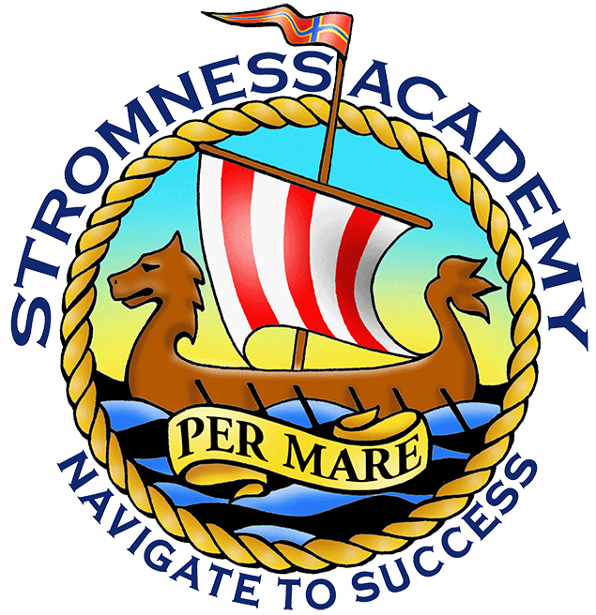

2. Pupil Workbook

Name:

Thinking about your choices

In the box below, list some of the university courses that interest you. Also, record what the entry requirements are at the different universities for this course. Is there any other useful information that will help you with your application and personal statement? Remember to use these useful tools: https://www.planitplus.net/Institutions/Universities/ and the ‘course search tool at the top left of: https://www.planitplus.net

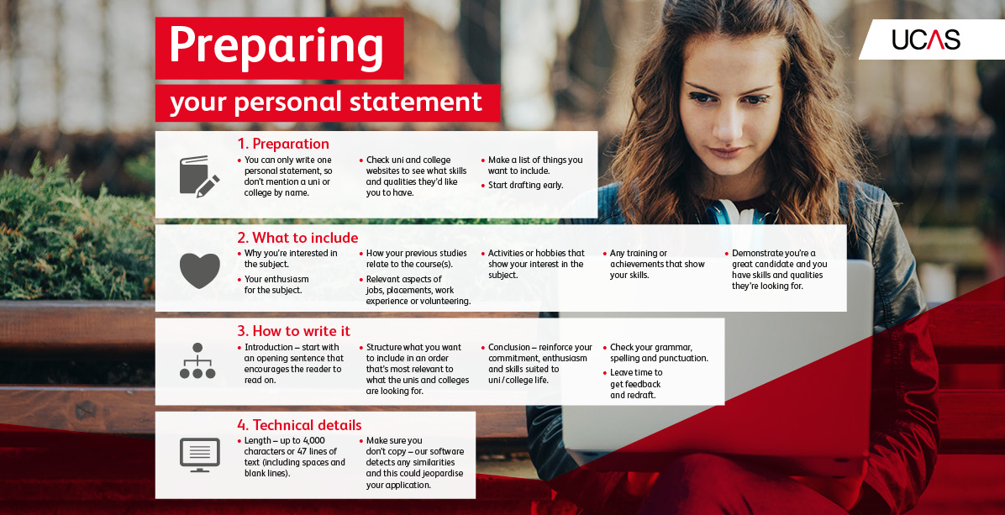

The following pages are designed to help you think about information you could include in your personal statement. We’ve included space for you to write down any thoughts you have as you go along.
Starting your personal statement

More detailed advice and guidance about writing your personal statement is in the supporting resource: “Orkney Schools Information Booklet”. Other useful support videos are available at: www.ucas.com/personalstatement
The boxes below will expand when you enter text in them.

Why are you applying for the course(s)?

Why does this subject interest you? Include evidence that you understand what’s required to study the course, e.g. if applying for psychology courses, show that you know how scientific the subject is.

Why do you think you’re suitable for the course(s)? Do you have any particular skills and experience that will help you to succeed on the course(s)?

Have you participated in any activities that demonstrate your interest in the course?

List the accredited and non-accredited achievements that you have below:

Do you have any positions of responsibility in or out of school that make you stand out from the crowd?

List all of your hobbies and interests and explain the skills you have gained from them and how they link to the course.

Include details of jobs, work experience or voluntary work that you have undertaken, especially linked to your chosen course. List the skills and qualities you developed from them linked to your course.

What are your future plans linked to your career? What do you want to do with your degree after university?

