ORKNEY SCHOOLS PEEDIE OLYMPICS 15TH-26TH JUNE 2020
PE PARTICIPATION PACK
Dear pupils and parents,
Welcome to the Orkney Schools Peedie Olympics Fortnight! We hope that you and your family have great fun taking part.

You should…
- Be able to find most items of equipment around the house or garden. If you can’t find something, can you use your imagination to find an alternative?
- Adapt the activities to make it fair, so all members of the family can have fun while taking part.

You can…
- Choose whether you do some, or all, of the activities.
- Choose when to do the activities.
- Watch the instruction videos for all the activities on https://www.youtube.com/playlist?list=PL1gP0ieimtMndP3VsWNX6dPxgQFCoFuGI
- Choose whether you do them all in one day or do some each day during the fortnight.
- Choose whether you record your scores to challenge other members of your family – or even challenge a friend and their family!
- Choose which activities to do inside and which to do outside.
- Adapt any activity to suit your space or equipment.
- Take a video and send it to Active Schools. They might post it on their Facebook page.

Why don’t you…
- Choose your favourite country and see if you can find something to wear in that country’s colours?
- All choose different countries or colours?
- Be creative and choose how you organise your event, for example have an opening ceremony?

BUT MOST OF ALL…HAVE FUN!
SUGGESTED EQUIPMENT LIST

- At least 10 pairs of socks
- 1 Laundry Basket (or bucket)
- 6 Medium to Large Plastic Bowls/ targets
- Paper (to keep tally points) or score sheet
- Pencil or Pen
- 1 Empty Water Bottle
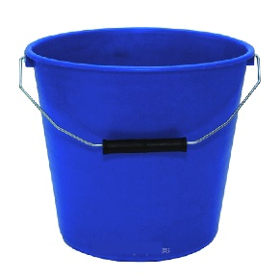
- Oversized T-Shirt, Shorts, and a Hat or similar
- Some Plastic Cups
- Clock or Stopwatch
- 3 Balloons or plastic bags
- 10 Clothing Items
- 1 Kitchen Spatula
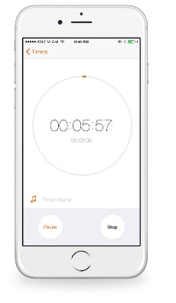
- 1 Plastic Container Lid
- 5 to 10 Pairs of Shoes/trainers
- 3 to 6 Sheets of Paper (for making airplanes)
- Sheet of newspaper for runway
- Seek It Oot Worksheet
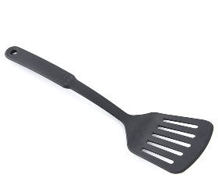
- 1 Medium-sized Bucket
- 1 Plastic (Tupperware) Container
- 1 Spoon
- 1 Small Object that Fits in Spoon
- 1 Large Towel
- Something to make goals out of
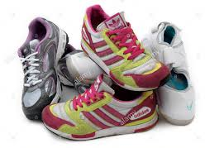
- Measuring jug
- Markers – cones, tins, bins – anything to mark course
- Straight markers like rulers or unfolded socks, string etc
- Items for the In an’ Oot an’ Roondaboot course
- Cut out floonder from newspaper
- Folded newspapers/ paper plates/ cardboard fan
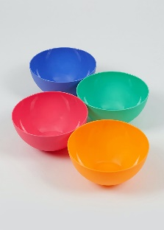
- Step, chair, stairs
- Something to skip with
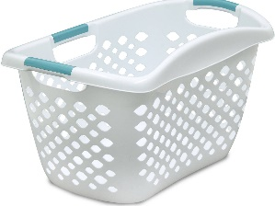
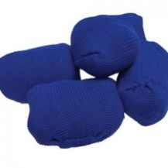
- Cardboard or newspaper

No 1: Goal!
Get Ready:
Something you can use as a goal; netball post, football goal, bucket, bowl, cup
target – a good guide is 1 body length from the target. That way it is fair
when competing against older or younger people in your family. Something to
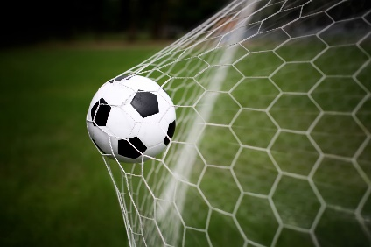
use as a ball. Stop watch or timer.
Get Set:
Stand with your body behind the marker and have your object(s)
ready to throw or kick.
GO!
The object of the game is to see how many goals you can score in
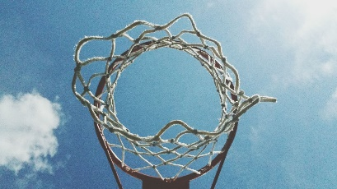
1 minute? You score 1 point for each successful shot. If you wish to,
you can write your total number of points on the Score Card.
Why don’t you……
Try from different distances away, give more points for shooting from
different spots or see how quickly you can get to 10 points.
Watch video 1 to see how it’s done:
Link: https://www.youtube.com/playlist?list=PL1gP0ieimtMndP3VsWNX6dPxgQFCoFuGI

No 2: LAUNCH THE LACE-UP
Get Ready:
1 Slipper or trainer
Get Set:
Make sure you have plenty of safe space around you.
GO!
The object of the game is to see how many points you can score
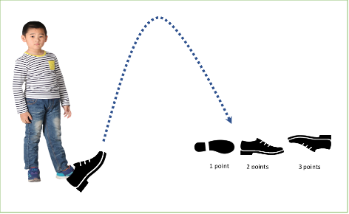
in 1-minute? To play you must put the end of your foot in the shoe
and when someone signals for you to start you must flip the slipper
or shoe up in the air and see how it lands on the floor. You score points
depending on how it lands.
1 point = shoe lands on its side
2 points = shoe lands right side up (sole of the shoe on the ground)
3 points = shoe lands perfectly upside down (no sides touching the ground)
0 points = if the shoe hits you on the head or knocks over a lamp.
You can write your total number of points on the Score Card if you want to.
Why don’t you……
Try with different shoes to see what works best. Race against someone
else and see who can get to 10 points first.
Watch video 2 to see how it’s done:
Link: https://www.youtube.com/playlist?list=PL1gP0ieimtMndP3VsWNX6dPxgQFCoFuGI

No 3: FLIP THE CLOOT
Get Ready:
1 large beach or bath towel (cloot). Stop watch or timer.
Get Set:
Lay your towel out flat on your floor and stand on it.
GO!
The object of the game is to flip the towel without stepping off
it within the 1 minute timer. You can take small steps from one part
of the towel to another but you can only move it when you have both
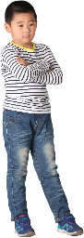
feet firmly in place on top of the towel. The towel must be flat at the
start and flat at the finish.
You can record how quickly you can flip your towel on the
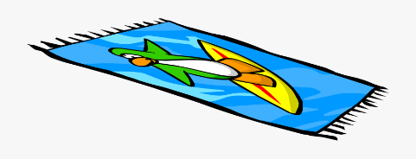
score sheet if you want to.
Why don’t’ you…..
You can give yourself more time to complete the challenge or use a
bigger or smaller sized towel.
Watch video 3 to see how it’s done:
Link: https://www.youtube.com/playlist?list=PL1gP0ieimtMndP3VsWNX6dPxgQFCoFuGI

No 4 BEAT THE TIDE
Get Ready:
Bucket or basin of water and an empty container with a level marked on it.
A plastic cup with or without holes which is much smaller than the empty
container. Stop watch or timer.
Get Set:
Check you have a safe area to move in. Fill your bucket with water
and place it at the start along with your plastic cup. At the opposite
end, place your empty container with the marking on it. Distance apart
should be judged by the family to make sure it’s fair for everyone.
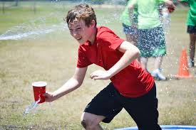
GO!
The object of this game is to see how quickly you can fill the empty
container to reach the level mark. (before the tide comes in!)
You can only fetch water in your plastic cup and have to run/walk
back and fore as many times as it takes to reach the mark on your
container. You can write your time on the score card if you want to.
Why don’t’ you…
Try with a cup with holes in it to make the challenge more difficult!
Race against someone else in your family and see who can do it the
fastest. Have an obstacle that you have to go over/under whilst
holding your cup of water.
Watch video 4 to see how it’s done:
Link: https://www.youtube.com/playlist?list=PL1gP0ieimtMndP3VsWNX6dPxgQFCoFuGI
No 5 SPRINT
Get Ready:
Decide and mark out your running area. This could be your round your house
or garden, round cones, tins or anything you can find – even a chalk marked area.
Stop watch or timer.
Get Set:
Check the area you are about to work in is safe. Have someone ready
to time you!
GO!
The object of this game is to see how quickly you can run round your
marked area. Stand behind your starting point and on the signal run as
fast as you can. You are finished when you reach the finish line.
You can write your time on the score card if you want to.
Why don’t’ you…
Increase the number of times you have to run around.
Try racing against somebody else in your family to see who is
fastest.
See how many laps you can complete in a set time.
Watch video 5 to see how it’s done:
Link: https://www.youtube.com/playlist?list=PL1gP0ieimtMndP3VsWNX6dPxgQFCoFuGI

No 6 KEEPIE UPPIE
Get Ready:
Have up to 3 balloons per person ready to play with. If you don’t
have any balloons you can use plastic bags that have been tied at the
handles to keep the air in.
Get Set:
Make sure you are in an open space with lots of room to move
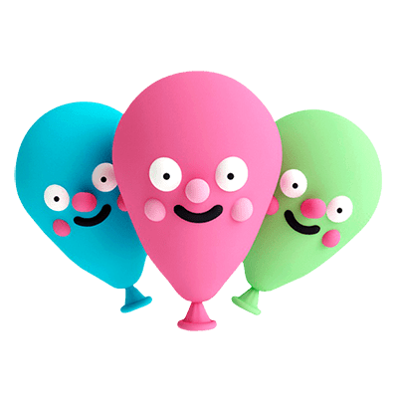
around in. Choose whether you want to start with 1, 2 or 3 balloons.
GO!
The object of this game is to keep your balloon(s) off the floor!
Using only your hands, how many times can you hit the balloons to keep
them up in 1 minute. If you are using more than 1 balloon to play, you are
not allowed to hit the same balloon twice in a row! Each time you hit a
balloon up with your hand it will count as 1 point, try to keep count
yourself or you could have an adult help you count. If a balloon falls to
the floor, just pick it up and keep going! At the end of the 1 minute,
write down your total number of points on the score sheet if you wish.
Why don’t you…
Try with one balloon to start with.
Try to make it harder by starting from 0 if a balloon touches the floor.
Watch video 6 to see how it’s done:
Link: https://www.youtube.com/playlist?list=PL1gP0ieimtMndP3VsWNX6dPxgQFCoFuGI
No 7 SEEK IT OOT!
Get Ready:
You will need a copy of the Seek it Oot worksheet or write a list
of all the items on the sheet on a separate piece of paper.
Get Set:
Have your worksheet or list with you. Everything you are looking for
should be somewhere in your house or in your garden.
GO!
The object of this game is to find as many of the items on the worksheet
as possible in 5 minutes. You must look around your house and/or garden to
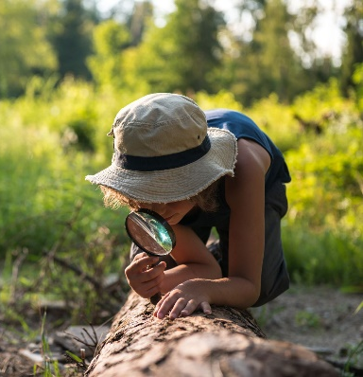
try and find these items. Each item you find will be worth 1 point. Every time
you find an item make sure you tick/score it off on your worksheet or list
so you can see what you still need to find. At the end of the 5 minutes you
can record your score if you wish.
Why don’t you…
Try to race against a family member – who can find the most
in 5 minutes?
Try to find all of the items on the worksheet and see how long it
takes – keep going after the 5 minutes are up and record your time
instead of your score.
Watch video 7 to see how it’s done:
Link: https://www.youtube.com/playlist?list=PL1gP0ieimtMndP3VsWNX6dPxgQFCoFuGI

No 8 BA’ SMUGGLE
Get Ready:
You will need a pair of socks, a tennis ball or even a potato for
the Ba’ and 2 (plastic) cups.
Get Set:
Lie down on the ground and place 1 cup at your head and 1 cup at your
feet. This will be the distance you need to travel between during the
challenge. Make sure that 1 cup starts upside down and the other sitting
the right way up.
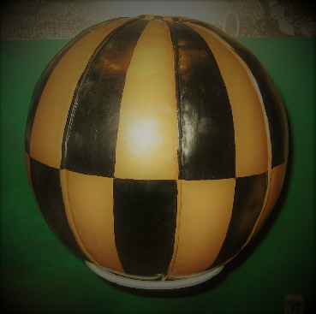
GO!
The object of this game is to carry the Ba’ between your legs while walking
between the 2 cups. Each time you arrive at a cup, you must turn it over while
keeping your Ba’ between your legs. Each time you turn over a cup, you will
score 1 point. Try to score as many points as you can in 1 minute without
dropping you’re the Ba’! If you do drop the Ba’, you must do 5 star jumps before
you are allowed to carry on with the challenge. Write down your total number
of points on the score sheet if you wish.
Why don’t you…
Set a target number of points you want to score.
Challenge a family member – who turns over the most cups in 1 minute or first
person to turn over 6 cups is the winner. Make the cups further away from each other for older people
Watch video 8 to see how it’s done:
Link: https://www.youtube.com/playlist?list=PL1gP0ieimtMndP3VsWNX6dPxgQFCoFuGI
No 9 TATTIE TRUNDLE
Get Ready:
You will need a spoon (this may be a wooden spoon or even a spatula or bat)
that is big enough to hold a tattie (this can be an egg, a tattie, a ball or
a pair of socks). You will also need something to mark out 2 points that you
must run between – cones, jumpers, shoes – anything will do!
Get Set:
Decide on how far about you want your markers to be making sure you make the
distance bigger or smaller depending whose shot it is.
Once you have your markers set out, choose which one you
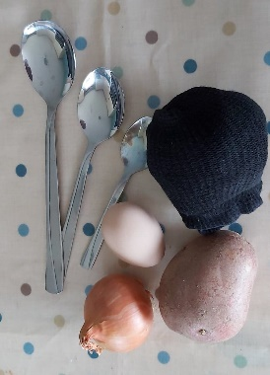
want to start at and make sure you have your tattie and spoon with you!
GO!
The object of this game is to do as many laps as you can in 1 minute. 1 lap is when from
your starting marker, to the opposite marker and back to the start. If you would rather
run laps around the outside of your markers, 1 lap should be counted every time you pass
the start marker. If you drop your tattie, you must stop, pick it up and place it back on
your spoon then carry on again. Write down your total number of points on the score sheet
if you wish.
Why don’t you…
Try to move your markers further away to make it harder.
Try to make it harder by only counting the laps when you didn’t drop your tattie.
Watch video 9 to see how it’s done:
Link: https://www.youtube.com/playlist?list=PL1gP0ieimtMndP3VsWNX6dPxgQFCoFuGI
No 10 RAT TRAP
Get Ready:
You will need a water bottle (Rat), a basket or bucket, a ball or something you
can roll and a marker for your start line.
Get Set:
Set your water bottle on the ground then balance one edge of your basket or
bucket on top of your bottle to create a trap. Decide how far away from
the start line you want to be – the easiest way to measure this is to lie down
with your feet in front of your trap then place your marker at your head.
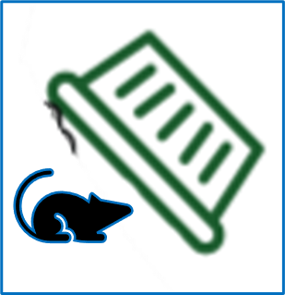
Maybe measure twice that distance. Stand at the start line with your ball ready to roll.
GO!
The object of this game is to roll your ball from behind the start line and try to
hit the water bottle (Rat) to make the trap fall. You must hit the water bottle to
score points in this game – it won’t count if you hit the basket/bucket with your
ball and it then falls down.
1 point = Basket falls and traps only the ball
2points = Basket falls and traps only the bottle (Rat)
3 points = Basket falls and traps both the ball and the bottle (Rat)
Try to score as many points as you can in 1 minute! Be sure to set the trap back up before you take your next shot! Write down your total number of points on the score sheet if you wish.
Why don’t you…
Try to get a family member to fix the trap for you after each shot.
Try to make it harder by starting from further away or by using a smaller or lighter ball.
Watch video 10 to see how it’s done:
Link: https://www.youtube.com/playlist?list=PL1gP0ieimtMndP3VsWNX6dPxgQFCoFuGI
No 11 FOLD YER KLAISE
Get Ready:
10 Clean Clothing Items from a Laundry Basket for each Player
Get Set:
Place the 10 items from your Laundry Basket in a pile next to you.
GO!
The object of this game is to score points by folding each item (shirt,
trousers, shorts, etc.). You have 1 minute to fold as many as possible.
On the start signal, begin folding each piece of laundry. Score 1 point
for each piece of laundry folded in one minute. Max 10 points. Write
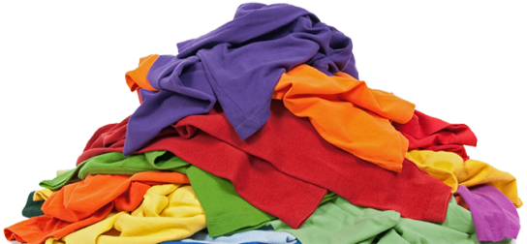
your score down on your score sheet if you wish.
Why don’t you…
Have different numbers of items or different scores for younger or
older family members
Have easier or more difficult items to fold to make sure everyone
enjoys the challenge.
Watch video 11 to see how it’s done:
Link: https://www.youtube.com/playlist?list=PL1gP0ieimtMndP3VsWNX6dPxgQFCoFuGI

No 12 LEAP OWER THE BURN
Get Ready:
Get 4 markers ready (rulers, spoons or something similar)
Lie down on the floor/grass and get someone to mark where your
feet, waist, neck and head are, as in the diagram.
Get Set
Stand with your feet behind the first (feet) marker.
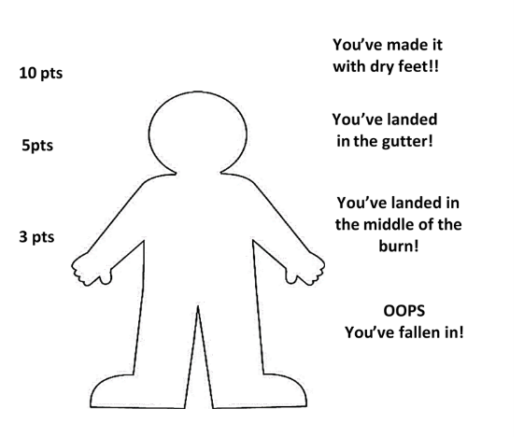
Bend your knees and swing your arms behind you
Lean forward until you are about to fall.
Go!
Swing your arms forward and push off your feet to jump as far
as you can.
Keep your head up and your arms in front of you to help you
keep your balance.
Ask someone to measure how far you have jumped. (Measure to
the part of you closest to the start line – hopefully your heel!)
Why don’t you:
Add an extra score for getting beyond your head
Watch video 12 to see how it’s done:
Link: https://www.youtube.com/playlist?list=PL1gP0ieimtMndP3VsWNX6dPxgQFCoFuGI

No 13 IN AN OOT AN ROONDABOOT
Get Ready:
You need to use your imagination to design and create an obstacle course
either inside or outside your house. Check with an adult that the items
you find and the space you intend to use are safe. Think about using items that you
can mark out pathways to travel in, e.g. forwards/backwards/sideways and things
you can go in/out off and over/under/through. Decide where to start and finish
and mark them clearly. This diagram might give you some ideas.
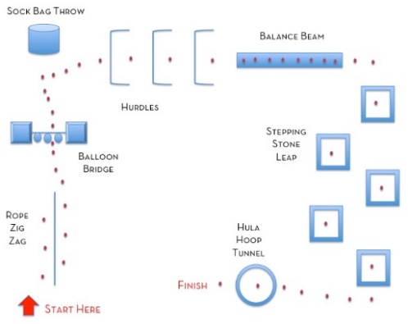
Ask someone to time you using a stopwatch or phone.
Get Set:
Have a practice first or go through the course in your mind
so you know where to go and what to do.
Stand with your feet behind the start line.
Go:
Zoom through the obstacle course as fast as you can,
remembering to do all the activities in the right order
and to cross over the finish line before stopping.
Record your time if you wish
Why don’t you:
Have different numbers of activities or laps for younger or older family members to make sure everyone enjoys the challenge.
See how many laps you can do in 1 minute.
Carry a cup of water to see how much is left at the end.
Watch video 13 to see how it could be done:
Link: https://www.youtube.com/playlist?list=PL1gP0ieimtMndP3VsWNX6dPxgQFCoFuGI

No 14 DRESS UP AND DAB!
Get Ready:
Find 3 items of clothing which are oversized. These could be a tshirt, hat,
shorts, skirt, dress etc
Mark out a Start/Finish and a check point at either end of the safe space
you are using. You can decide how far apart they should be
Find a Clock, Stopwatch or Phone for timing
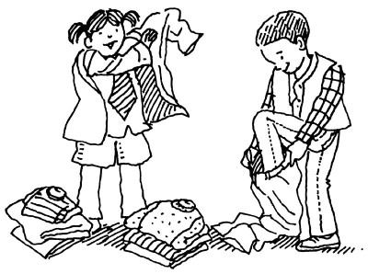
Get Set:
Put the 3 items of clothing at the check point opposite the start point,
Stand with your feet behind the starting line
GO:
On the Go signal, run as fast as you can up to the pile of clothes and put
on one of the items. Sprint back and touch the start line before zooming
back to the pile of clothes. Grab another item and put it on before running
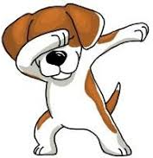
back to the start line. Touch the line before racing back for the 3rd item of
clothing. Put it on and race back over the line. As soon as you are over the line
Dab to show you are finished! Note or record your time if you wish
Why don’t you:
Find 3 items of clothing for each person taking part and then race against each other
at the same time.
Vary the distance to the check point for younger or older members of the family
Find easier or harder items of clothing to put on to make sure the challenge is fun
Watch video 14 to see how it could be done:
Link: https://www.youtube.com/playlist?list=PL1gP0ieimtMndP3VsWNX6dPxgQFCoFuGI
No 15 FLIP THE FLOONDER
Get Ready:
Cut out a Fish/floonder from a piece of scrap paper or newspaper.
Make a fan out of another newspaper, piece of cardboard or paper plate.
Decide how far the race is going to be and mark the start and the finish.
This race is probably best done inside so the wind doesn’t blow the fish away!
Get Set:
Everyone places their Fish/floonder just in front of the start line
and they stand behind it.
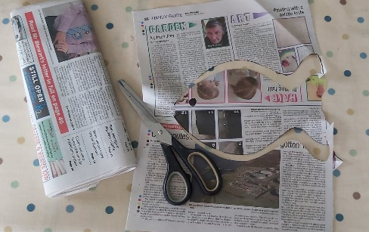
GO!
On the word GO, start flapping your newspaper/paper plate up and
down to create a breeze to move your fish/floonder along towards the
finish. The first person to get their fish over the line is the winner.
Why don’t you…
Allow younger members of the family to start closer to the finish
The older members could start further back or try doing it with one
hand behind their back
If there isn’t much space, you could go one at a time and see who can
do it fastest.
Watch video 15 to see how it could be done:
Link: https://www.youtube.com/playlist?list=PL1gP0ieimtMndP3VsWNX6dPxgQFCoFuGI

No 16: THE OLD MAN OF HOY

Get Ready:
5-10 shoes per player,
1 spot marker per player to create a home base for each player such
as a paper plate.
Get Set:
Place all the shoes in a pile in the centre of the room.
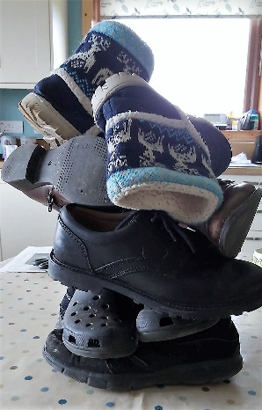
Place the home base spots equal distance apart from the other
players.
GO!
The aim of this event is to build the Old Man of Hoy with the shoes
collected from the pile. On the signal, players will run and take
one shoe from the pile, return it to their home base and place
it on their stack. Repeat till all the shoes are gone. If your
Old Man falls, that’s ok, you may rebuild it and then continue.
On the stop signal, count and score 1 point for each shoe in the stack
Why don’t you…
Try from different distances away from the pile of shoes.
Try different ways of building up the shoes to increase the height of your stack.
Watch video 16 to see how it’s done:
Link: https://www.youtube.com/playlist?list=PL1gP0ieimtMndP3VsWNX6dPxgQFCoFuGI

No 17: BUTTER SIDE DOWN

Get Ready:
1 tupperware/plastic lid, kitchen spatula
Get Set:
The aim of this game is to flip your lid upside down to earn points.
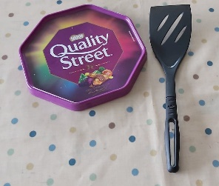
Go !
Place the lid facing up on the table of floor, then slide the spatula
under and flip the lid in the air. Let the lid land flat on the table or
floor. Score a point every time you manage to flip the lid upside down
(0 points if it lands the right-side up). Quickly reset the lid after each
0 POINTS
attempt. You have 1 minute to score as many points as possible.
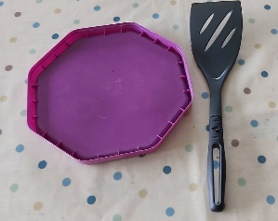
Why don’t you…
Try flipping the lid with your other hand (the hand you don’t write with).
Watch video 17 to see how it’s done:
Link https://www.youtube.com/playlist?list=PL1gP0ieimtMndP3VsWNX6dPxgQFCoFuGI
1 POINT

No 18: RICOCHET

Get Ready:
5 large sock balls, laundry basket or bucket, a wall.
Get Set:
Roll up the socks to make sock balls. Place the basket or bucket against
the wall. Mark a distance from the basket (you could use your body
length as a measurement).
GO!
The aim of this game is to score as many points as you can in 1 minute,
by tossing the sock balls off the wall and into the basket. You must use
the wall as your backboard and land the socks into the basket.
Keep your score.
Why don’t’ you…
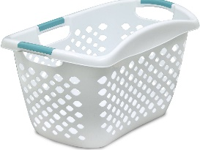
Try different distances and angles from the wall.
Watch video 18 to see how it’s done:
Link https://www.youtube.com/playlist?list=PL1gP0ieimtMndP3VsWNX6dPxgQFCoFuGI

No 19: UP AND DOON

Get Ready:
Find a step somewhere about the house. Inside or outside. If you don’t
have a step can you use a chair or some book (watch they don’t slip though)
Get Set:
Choose a target number of steps i.e. 100. Have someone ready to count your
steps and to time your challenge.
GO!
The aim is to achieve your target number of step ups in the fastest time
possible. One count is right foot up, left foot up, right foot down, left
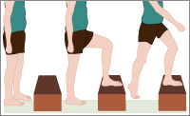
foot down (or vice versa). Your whole foot must step up, not just your
toes as you may slip off the step. It doesn’t count if you jump down off
the step.
Why don’t you…
Try a different target number of step ups.
Watch video 19 to see how it’s done:
Link https://www.youtube.com/playlist?list=PL1gP0ieimtMndP3VsWNX6dPxgQFCoFuGI

No 20: EGG IN THE NEST

Get Ready:
6 bowls(nests), 1 sock ball, paper and pencil to keep score.
Get Set:
Set the bowls on the floor in a triangle pattern roughly
10 to 15 cm apart. Put a piece of paper with different amounts
of points written on it inside each bowl(nest). Mark a throwing line as a
3
distance to throw the sock ball from.
GO!
2
2
The aim of this event is to try and score the most points possible
within one minute. Start by standing behind the throwing line try
1
1
1
1
1
1
1

1
and get the sock ball to land directly into a nest. After each throw,
retrieve the sock ball and race back to the throwing line to throw
again. If a sock lands in a nest, make a note of the points scored for
the nest. If it bounces back out you score half the points for that nest.
After 1 minute, calculate your total score.
Why don’t’ you…..
Try different size bowls or try being further away from them.
Give the name of a bird to each nest. Big birds for the nearest ones and smaller birds for the harder ones.
Watch video 20 to see how it’s done:
Link https://www.youtube.com/playlist?list=PL1gP0ieimtMndP3VsWNX6dPxgQFCoFuGI

No 21 SOCK PUTT
Get Ready:
One pair of the socks for each player and a marker line
Get Set:
Mark out a line that you and the other players can stand behind.
Stand side on with your left foot on the line. Put the sock in your right hand,
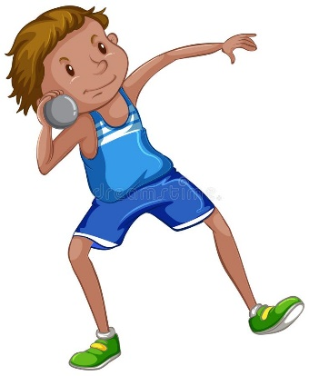
under your chin and stick your left hand up in to the air. (opposite sides if
you are left handed.)
GO!
The object of this game is to throw your pair of socks as far as you can.
Each player has 3 shots at throwing their sock and the furthest pair of
socks win.
Why don’t you…
Start younger players further up or give them a lighter pair of socks.
Watch video 21 to see how it’s done:
Link: https://www.youtube.com/playlist?list=PL1gP0ieimtMndP3VsWNX6dPxgQFCoFuGI

No 22 LAND THE ISLANDER PLANE
Get Ready:
Three pieces of paper, a newspaper and a timer

Get Set
Create 3 paper islander planes and stand behind a marker with your

newspaper (runway) 5 big strides away.
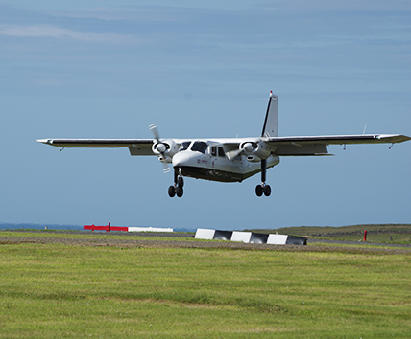
Go!
You have 1 minute to throw your planes onto the runway (newspaper)

as many times as you can. When the 1 minute is up, you can try and
beat that score or someone else can try and beat it.

Why don’t you:
Change the distance from the runway depending on the age of person
playing.
Watch video 22 to see how it’s done:
Link: https://www.youtube.com/playlist?list=PL1gP0ieimtMndP3VsWNX6dPxgQFCoFuGI

No 23 SKIPATHON
Get Ready:
Skipping rope, a dressing gown tie or be creative with newspaper
and tape!
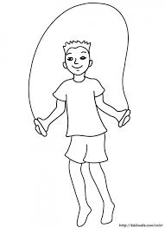
Get Set:
Find a space that you can skip without knocking anything over.
GO!
See how many skips you can do in a row without stopping!
Why don’t you…
You could time yourself and challenge someone else!
Watch video 23 to see how it’s done:
Link: https://www.youtube.com/playlist?list=PL1gP0ieimtMndP3VsWNX6dPxgQFCoFuGI

No 24 A ROO O’ SOCKS
Get Ready:
10 pairs of socks, one marker line and a timer
Get Set
Unpair your 10 socks and mix them up in a space on the floor,
choose a starting point 5 giant steps away and put down your marker line.
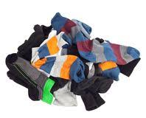
Go!
When someone shouts go! You can run from your marker line and pick
up one sock at a time to bring back to your marker line. Once you have
collected back all 20 socks, try and pair them as fast as you can.

Why don’t you:
Challenge someone to see who can do it the quickest? Choose
different colours of socks to make it easier or similar colours to
make it harder. Can older children or parents do this with one hand?
Watch video 24 to see how it’s done:
Link: https://www.youtube.com/playlist?list=PL1gP0ieimtMndP3VsWNX6dPxgQFCoFuGI
No 25 WAFT THE BALLOON
Get Ready:
One balloon, blown up plastic bag or ping pong ball. Two big bits of
cardboard
Get Set:
Place the balloon on a table and have a player either side of it.

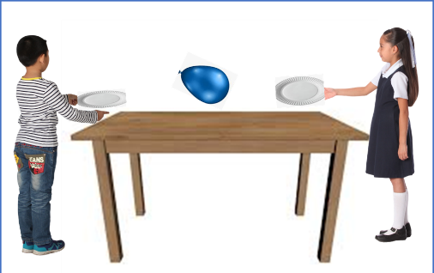
GO!
The object of this game is waft the balloon off your opponent’s
side of the table as fast as you can!
Why don’t you…
Do it yourself and time how fast you can waft the balloon off?
Compete against more people?
Have different sized fans depending on the age.
Watch video 25 to see how it’s done:
Link: https://www.youtube.com/playlist?list=PL1gP0ieimtMndP3VsWNX6dPxgQFCoFuGI

SEEK IT OOT
CAN YOU FIND A…
OR SOMETHING…
BLUE | BEGINNING WITH ‘A’ | THAT FLOATS | SMALLER THAN A PENNY
YOU CAN EAT THAT IS RED | ROUND | THAT YOU CAN BALANCE ON | BEGINNING WITH ‘R’
YOU CAN WEAR ON YOUR HEAD | ORANGE | SQUIDGY | A PAPER CLIP
WITH A NUMBER ON IT | FLUFFY | MADE OF WOOD | WITH A FACE ON IT
GREEN | THAT YOU CAN JUMP OVER | WITH A DATE ON IT | WITH FLOWERS ON IT
3 SIDES | WITH ANIMAL PRINT ON IT | BLACK | SQUARE
WITH A FLAG ON IT | YOU CAN HIDE IN | WITH A CROWN ON IT | THAT SMELLS NICE
STARTS WITH THE FIRST LETTER OF YOUR NAME | IS HEAVIER THAN YOUR SHOE | HAS A LETTER B ON IT | MADE OF METAL

SCORE CARD
NAME:___________________________
NO | EVENT | ATTEMPT 1 | ATTEMPT 2 | PERSONAL BEST
1 | GOAL!!
2 | LAUNCH THE LACE-UPS
3 | FLIP THE CLOOT
4 | BEAT THE TIDE
5 | SPRINT
6 | KEEPIE UPPIE
7 | SEEK IT OOT
8 | BA SMUGGLE
9 | TATTIE TRUNDLE
10 | RAT TRAP
11 | FOLD YER KLAISE
12 | LEAP OWER THE BURN
13 | IN AN’ OOT AN’ ROONDABOOT
14 | FLIP THE FLOONDER!
15 | DRESS UP AND DAB
16 | OLD MAN OF HOY
17 | BUTTER SIDE UP
18 | RICOCHET
19 | UP AND DOON
20 | EGG IN THE NEST
21 | SOCK PUTT
22 | LAND THE ISLANDER
23 | SKIPATHON
24 | A ROO O’ SOCKS
25 | WAFT THE BALLOON

