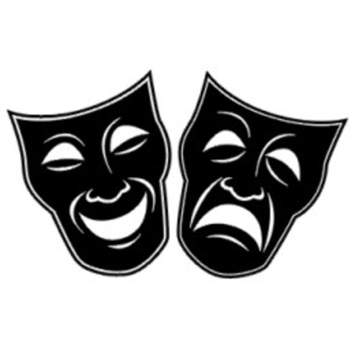

**National 5 Drama**

***Revision Booklet***

**Contents Page**

Drama Process Page 3

Structure Page 4

Theatre Conventions Page 5

Purpose Page 6

Target Audience Page 7

Drama Form, Genre & Style Page 8

Key Moments Page 10

Movement Page 11

Voice Page 13

Performance Concepts Page 14

Production Areas Page 15

Rehearsal Activities/Characterisation Techniques Page 17

Role, Purpose and Motivation of Character Page 19

Status Page 20

Mood, Atmosphere and Tension Page 21

Staging and Venue Page 23

Areas of the stage Page 26

Question Areas. Page 27

National 5 Drama Vocabulary Page 28

General Drama Vocabulary List Page 29

The Theatre Stage & Production Areas Vocabulary Page 34

**What is a stimulus?**

* The starting point of a drama
* Anything which suggests ideas which can be developed into a drama.

**The Drama Process**

* Discussing stimuli to help generate ideas
* Discussing ideas for situation
* Experimenting with and selecting ideas for the development of the drama
* Considering drama form, genre and style
* Considering the target audience
* Developing character (using rehearsal activities)
* Planning overall structure for drama
* Reflecting and discussing improvements
* Organising, making decisions, solving problems
* Adding in production (lights, sound, costume, props, make-up and set)
* Rehearsing
* Presenting
* Reflecting/Evaluating

[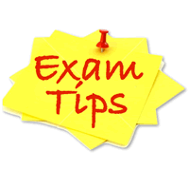](http://www.google.co.uk/url?sa=i&rct=j&q=&esrc=s&source=images&cd=&cad=rja&uact=8&ved=0ahUKEwiu_puEh5HPAhVJ7hoKHavTBo8QjRwIBw&url=http://opentuition.com/acca/acca-exam-tips-december-2012-exams/&psig=AFQjCNE5Y52hUbhrvSlQGQBYYNeDAFzYEw&ust=1474017979252445)You will need to consider all of the above for SECTION 2 of the exam when you will have to make notes and answer questions on an imagined devised piece of drama, and also for SECTION 1 where you had to apply many of the above to your practical exam piece.

Structure

___________________________________________

*Structure is the way in which your drama is put together in terms of time, place and action. You can choose to have either a* ***linear*** *or a* ***non-linear*** *structure.*

**Linear –** this is when the storyline follows in chronological order (beginning-middle-end).

**Non Linear** – this is when the action unfolds through shifts in time (flashback/flash-forward) and/or place.

Scene 1 (9.30am)



Scene 2

(Flashback 2 weeks earlier)



Scene 3 (9.30am)



Scene 4

(Flashforward 1 month later)

Scene 1 (Morning 9.30am)



Scene 2 (Afternoon 2pm)



Scene 3 (Evening 8pm)

Theatre Conventions

___________________________________________

*Theatre Conventions are alternative ways of presenting part(s) of a drama or scene. They allow you to communicate more effectively with your audience and make your drama more interesting to watch.*

|  |  |
| --- | --- |
| **Flashback** | *Acting out an event in the past* |
| **Flash-forward** | *Acting out of a future or imagined event* |
| **Freeze Frame** | *The action is frozen in time* |
| **Frozen Picture** | *Alternative word for tableau* |
| **Mime** | *Stylised form of movement which creates an illusion of reality* |
| **Monologue** | *A character speaks their thoughts aloud* |
| **Movement** | *Use of the body as a means of communication* |
| **Slow Motion** | *Movement performed at a slowed down speed* |
| **Narration** | *Part(s) of the drama are told as a story by a narrator* |
| **Voice Over** | *Recorded speech played during a drama* |
| **Aside** | *A remark to the audience only* |
| **Soliloquy** | *A single lengthy speech, made when no other characters*  *are on stage* |
| **Tableau** | *A stage picture, held without movement* |
| **Split Stage** | *When two or more scenes are set up on the performance space* |

[](http://www.google.co.uk/url?sa=i&rct=j&q=&esrc=s&source=images&cd=&cad=rja&uact=8&ved=0ahUKEwiu_puEh5HPAhVJ7hoKHavTBo8QjRwIBw&url=http://opentuition.com/acca/acca-exam-tips-december-2012-exams/&psig=AFQjCNE5Y52hUbhrvSlQGQBYYNeDAFzYEw&ust=1474017979252445)

You could be asked a conventions question in section 1 and/or section 2.

In section 1 you could be asked what conventions you used in your drama and why you used them. You would state what convention you used, how you used it and why you used it (what effect were you looking for).

In section 2 you could be asked what conventions you would use in your drama and why.

**Example:**

*Name two conventions you would use in your drama and, for each one, explain the advantage of using it.*

PURPOSE

_____________ _____________________________

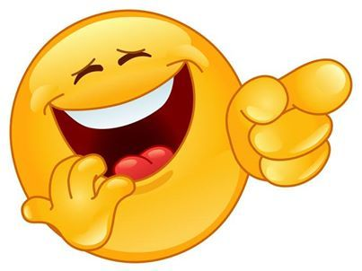

To **tell a story**

To **educate**

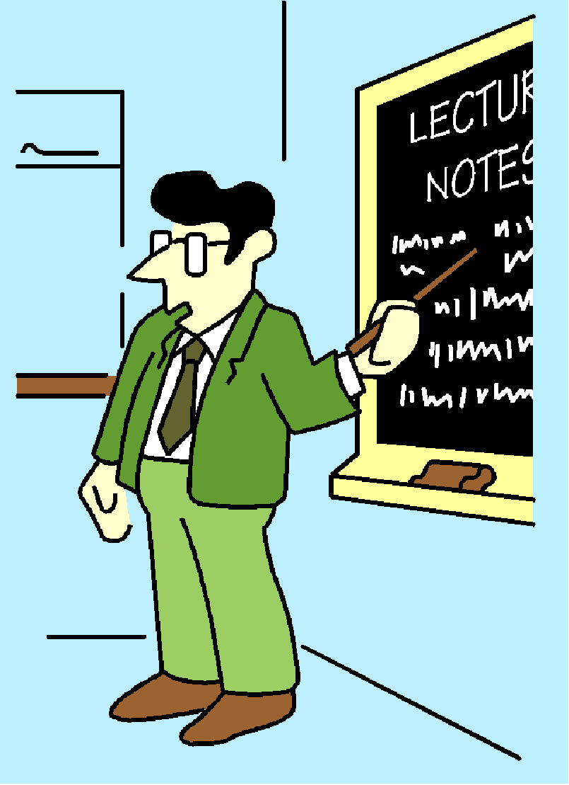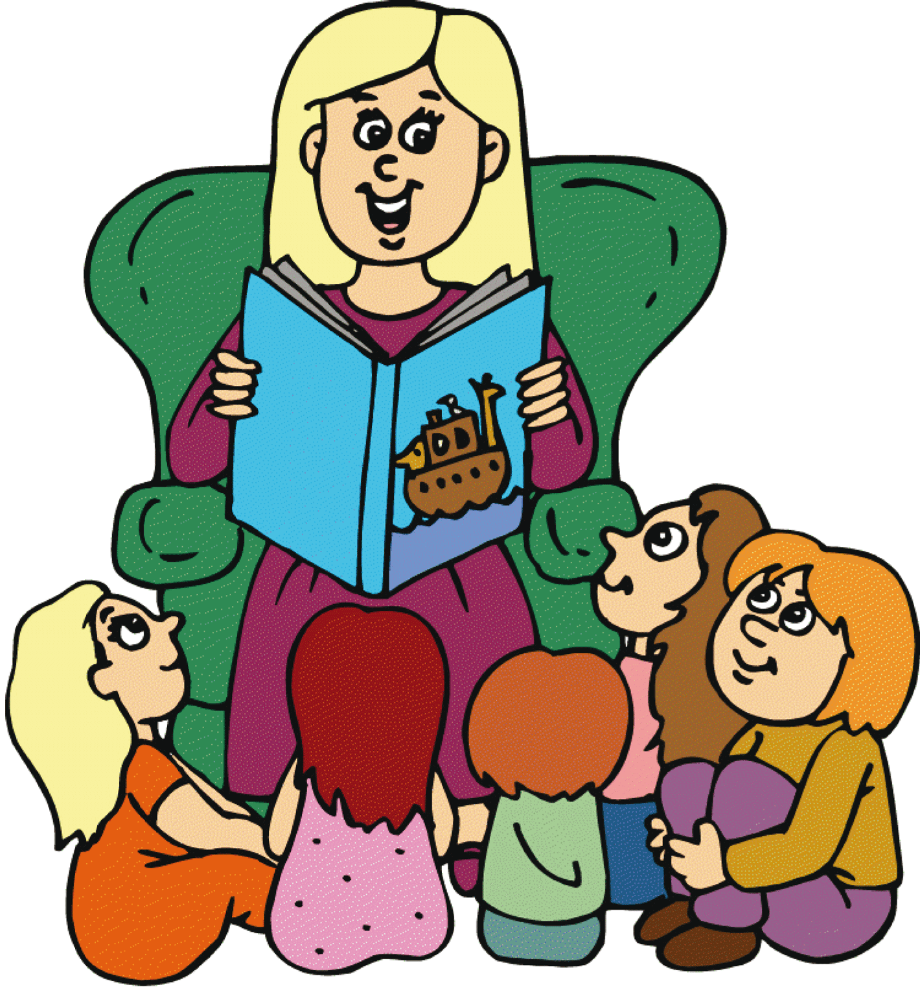

To **entertain**

*The purpose, or purposes, of a drama must be established in*  *order to communicate meaning.*



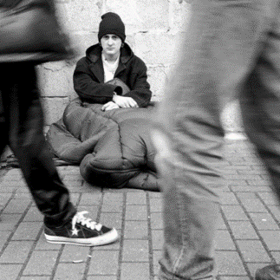

To **communicate a message**

C:\Users\Lucinda\AppData\Local\Microsoft\Windows\Temporary Internet Files\Content.IE5\742FCVCP\MC900198675[1].wmf

To **explore and experience**

To **explore a theme/issue**

Past Paper Example question:

Think about the purpose **or** message of your Drama. How will the plot and setting help communicate this purpose or message? (6 marks)

* Note the word “or” – this means write about one or the other. Although purpose and message are connected – there is a difference. For example, the message could be that “drugs are dangerous” so the purpose would be “to educate.”

[](http://www.google.co.uk/url?sa=i&rct=j&q=&esrc=s&source=images&cd=&cad=rja&uact=8&ved=0ahUKEwiu_puEh5HPAhVJ7hoKHavTBo8QjRwIBw&url=http://opentuition.com/acca/acca-exam-tips-december-2012-exams/&psig=AFQjCNE5Y52hUbhrvSlQGQBYYNeDAFzYEw&ust=1474017979252445)

Target Audience

Target Audience

___________________________________________



* If you want to identify an age group be specific about their age!
* Avoid general terms such as “Old people.” Instead you could write “the older generation between 65-80 years old”
* **Avoid giving a negative answer** to a target audience question (stating who would not enjoy watching your drama).
* You will be expected to give reasons for your answer.

A target audience is an identifiable group of people at whom a drama is aimed.

[](http://www.google.co.uk/url?sa=i&rct=j&q=&esrc=s&source=images&cd=&cad=rja&uact=8&ved=0ahUKEwiu_puEh5HPAhVJ7hoKHavTBo8QjRwIBw&url=http://opentuition.com/acca/acca-exam-tips-december-2012-exams/&psig=AFQjCNE5Y52hUbhrvSlQGQBYYNeDAFzYEw&ust=1474017979252445)

Who would you consider to be an appropriate target audience for your

drama? Give a reason for your answer.

**EXAMPLE:** The appropriate target audience for my drama would be teenagers aged between 17-19. This is the age bracket where most young people will learn how to drive. The drama will therefore be easily relatable to them and will enable them to be educated on important issues.

Drama Form, Genre & Style

___________________________________________

|  |  |
| --- | --- |
| **FORM** |  |
| **A Play, Scripted or Improvised** | *Another word for a drama* |
| **Dance drama** | *A drama presented through dance moves* |
| **Mime** | *Stylised form of movement which creates an illusion of reality* |
| **Monologue** | *A character speaks their thoughts aloud* |
| **Movement** | *Use of the body as a means of communication* |
| **Musical** | *Drama which includes song and/or music* |
| **Pantomime** | *Christmas theatrical entertainment usually based on a fairy tale* |
| **Forum theatre** | *The audience suggest changes to a drama in order to affect outcomes* |
|  |  |
| **GENRE** |  |
| **Comedy** | *A drama which is funny/comical* |
| **Tragedy** | *A drama about unhappy events and with a sad ending* |
| **Crime drama** | *A drama based on crime* |
| **Docudrama** | *A documentary style drama, including reconstructions of events* |
| **Commedia dell ‘artre** | *A theatrical form characterised by improvised dialogue and a cast of*  *colourful stock characters; masks are usually worn* |
| **Farce** | *A* [*comedy*](http://en.wikipedia.org/wiki/Comedy) *that aims at entertaining the audience through situations that*  *are highly exaggerated, extravagant and improbable.* |
| **Tragicomedy** | *A type of drama that blends aspects of both* [*tragic*](http://en.wikipedia.org/wiki/Tragedy) *and* [*comic*](http://en.wikipedia.org/wiki/Comedy) *forms* |
| **Satire** | *The use of humour, irony etc. to expose and criticise people’s*  *stupidity or vices* |
| **STYLE** |  |
| **Naturalistic** | *Imitating or reproducing real life* |
| **Non-naturalistic** | *Away from the norm, for example you would walk in a bizarre way* |

[](http://www.google.co.uk/url?sa=i&rct=j&q=&esrc=s&source=images&cd=&cad=rja&uact=8&ved=0ahUKEwiu_puEh5HPAhVJ7hoKHavTBo8QjRwIBw&url=http://opentuition.com/acca/acca-exam-tips-december-2012-exams/&psig=AFQjCNE5Y52hUbhrvSlQGQBYYNeDAFzYEw&ust=1474017979252445)

It is important that you do consider drama form, genre and style because you could be asked a question on it. When devising your next piece of drama in class, or when you move on to your acting pieces – take time to consider and think about these aspects.

**Example Past Paper questions:**

* What form would your drama take?
* Explain in detail the drama which the audience would see. In your answer you may include form, conventions used, genre and style of the piece.

Key Moments

___________________________________________

You could be asked to describe any of the following in your drama

* The opening of the drama
* The end of the drama
* A key moment
* A turning point
* The climax (peak) of the drama
* The most important or significant moment

Some of these could overlap. For example, your opening scene could be the most important moment. It is a good idea to know the significance of the opening of your drama, the end and then another key moment.

**What is a key moment?**

* One of the most important parts of the drama.
* 10-30 seconds (NOT a section of dialogue).
* You must justify your answer. Why is it important?
* Build up of tension.

*Please note that there has to be a build up of tension before the turning point/key moment/climax. You need to be prepared to justify any moment that you asked.

**Audience Response**

* how does it make them feel?
* What do they learn from it?
* Have they developed a feeling regarding a theme or message?
* Purpose – does it introduce or develop characters?

[](http://www.google.co.uk/url?sa=i&rct=j&q=&esrc=s&source=images&cd=&cad=rja&uact=8&ved=0ahUKEwiu_puEh5HPAhVJ7hoKHavTBo8QjRwIBw&url=http://opentuition.com/acca/acca-exam-tips-december-2012-exams/&psig=AFQjCNE5Y52hUbhrvSlQGQBYYNeDAFzYEw&ust=1474017979252445)

**You should be able to say how these moments or desired impact on audience could be shown by actors or any member of the technical team (lighting, set, etc.)**

Movement

___________________________________________

You need to know the following movement terms and be able to use them correctly.

**Naturalistic Movement:**

* **Body Language** – Messages given by the position or movement of the body.
* **Eye-contact** – Making eye-contact with another person
* **Facial Expression** – Look on face which shows emotion
* **Posture** – Position of the body, how it is held
* **Gesture** – Movement of hand/arm which communicates a meaning or emotion.
* **Use of Space** – How the actor moves in the acting area.

**Stylised Movement:**

* **Rhythm** – Movements which follow a pattern or beat.
* **Stance** – Attitude or position of the body.
* **Balance** – Keeping an even distribution of weight.
* **Speed/Pace** – Speed of an action or movement.
* **Timing** – Movement that is timed to an exact beat or sequence.
* **Positioning** – Placing of actors on stage.
* **Use of space** – Covering and using the performance space.
* **Use of direction** - Varying the direction actions/moves are presented.
* **Use of levels** - Varying the height at which movement etc are made.

[](http://www.google.co.uk/url?sa=i&rct=j&q=&esrc=s&source=images&cd=&cad=rja&uact=8&ved=0ahUKEwiu_puEh5HPAhVJ7hoKHavTBo8QjRwIBw&url=http://opentuition.com/acca/acca-exam-tips-december-2012-exams/&psig=AFQjCNE5Y52hUbhrvSlQGQBYYNeDAFzYEw&ust=1474017979252445)

When you are asked a specific question on movement – you **must** remember to use correct terminology listed above to gain marks.

**Example Past Paper questions:**

As a director, in what ways would you direct the actors to use their voice andmovement to help highlight this key moment?

Describe how these twocharacters would show their difference in status

through their use of movement.

Movement help sheet

**___________________________________________**

Describing the movement of a character will depend on their personality, relationships, motivations and the situation they are in. The following table acts as a guide to suggest possible movement (naturalistic) traits based on a person’s mood.

|  |  |  |  |
| --- | --- | --- | --- |
| **Mood** | **Eyes/ eye-contact** | **Facial expression** | **Posture, Gesture, Use of space** |
| Happy | Open wide, strong eye-contact, twinkling | Smiling, grinning mouth | Open gestures, upright posture, using a lot of space. |
| Sad | Looking at their feet, Limited eye-contact | Drooping mouth, upset expression | Slouched posture, dragging feet, using a limited amount of space, closed up body language. |
| Nervous | Erratic eye-contact, looking about quickly as they assess the situation. | Biting lips, scrunched up face | Gestures – biting nails, fidgeting  Use of space – pacing the floor  Slouched posture |
| Impatient | Rolling eyes, strong eye-contact with the person/object that is irritating them. | Raised eyebrows, pursed lips, unimpressed facial expression. | Gestures – tapping fingers, looking at watch.  Slouched posture  Moving erratically around the space. |
| Terrified | Eyes wide, staring at the one place (i.e. whatever is terrifying them) | Mouth open,  Scared facial expression. | Straight upright posture with high shoulders – tense.  Standing still – almost frozen in position.  Gesture – hands on face, over eyes. |
| Confident | Strong eye-contact with other people and when engaged in conversation. | Calm and collected facial expression (depending on the situation). | Upright posture, open and positive body language.  Initiates hand shake – confident gestures. |

Voice

___________________________________________

You need to know the following voice terms and be able to use them correctly:

* **Accent** – Way of speaking use in a local area or country.
* **Volume** – loudness or quietness of the voice.
* **Pace** – Speed of speech (fast or slow).
* **Pitch** – How high or low the voice is.
* **Tone** – Change of voice to express emotion.
* **Clarity** – Clearness of the voice.
* **Pause** – A break in speaking, a period of silence.
* **Emphasis** – The stress on a word or a phrase.
* **Articulation** – Clear pronunciation of words.
* **Intonation** – Rising and falling of voice in speech.
* **Fluency** – Natural flowing speech.
* **Register** – Ways of speaking, appropriate to the situation and/or the person being spoken to.

When you are asked a specific question on voice – you **must** use correct voice terminology to gain marks.

**Example Past Paper questions:**

- As a director, in what ways would you direct the actors to use their voice andmovement to help highlight this key moment?

- Describe how these twocharacters would show their difference in status through their use of voice.

[](http://www.google.co.uk/url?sa=i&rct=j&q=&esrc=s&source=images&cd=&cad=rja&uact=8&ved=0ahUKEwiu_puEh5HPAhVJ7hoKHavTBo8QjRwIBw&url=http://opentuition.com/acca/acca-exam-tips-december-2012-exams/&psig=AFQjCNE5Y52hUbhrvSlQGQBYYNeDAFzYEw&ust=1474017979252445)

Performance & Design Concepts

**___________________________________________**

In terms of acting, a performance concept may include:

* Social and cultural influences on ideas from the stimulus/text
* Influence of form, structure and genre on acting style
* Characterisation
* Character relationships
* Actor/audience relationships
* Staging
* Planned use of voice
* Planned use of movement

A **performance concept** is the overall interpretation of the character/text/stimulus that you want to achieve in performance.

In terms of technical, a design concept may include:

* Social and cultural influences on ideas from the stimulus/text
* Influence of form, structure, genre on design elements
* Staging
* Design concepts
* Theatrical effects

A **design concept** is the overall interpretation of the technical skill in relation to the characters/text/stimulus/other technical areas to achieve a certain look or feel for the performance.

Production Areas

___________________________________________

It is important to be familiar with the following production areas. You could be asked questions about them in section 1 and/or section 2 of your exam.

**Directing**

Directing is the process of interpreting a script or scenario, creating a directorial concept and then putting that into a performance – in conjunction with actors and the design team.

The directorial concept (the directors vision) defines the central themes, mood, tone and visual appeal of the performance.

The director is responsible for:

* The interpretation of the script/scenario
* Auditioning and casting
* Blocking the play
* Design and performance concepts
* The rehearsal process (planning and organising rehearsals)

**Lighting**

* On a basic level, lighting is used so that the audience can see what is happening on stage.
* Helps create atmosphere
* Can show time of day
* Helps show location
* Focuses audience’s attention on a specific area
* Creates special effects

**Sound**

* Helps create mood and atmosphere
* Helps to show location
* Create special effects and make drama more realistic (e.g rain, gun shots).
* Helps show time – time period and time of day
* Music can highlight an emotional or dramatic moment

**Set Design**

* Establishes where the drama is set (place and time)
* Helps create mood and atmosphere
* Set can show us a change in location (scene changes)
* Can give us insight into a particular character (e.g. if they live there).

**Props**

* Can establish time and place (both pre-set and personal)
* Personal props can give us more indication of a characters personality
* Can create mood and atmosphere

**Costume**

* Establishes where the drama is set (place and time)
* Gives us information about specific characters – hints at personalities.
* Can create mood and atmosphere
* Can help us show the status of a character.

**Make-up**

* On a basic level, makeup is used so the actors can be seen under stage lights.
* Shows the age and/or personality of the character.
* Can be used for special effects – e.g. cuts, burns, bruises.
* Can help with time and place of the drama.
* Make sure that you are aware of all the different areas of production. Be aware of why we use each one in performance – what advantages they bring, how they help create mood and atmosphere, how they help emphasise a key moment, etc.
* Be sure to know the appropriate vocabulary to describe each production area. E.g for lighting – blackout, fade-up, profile spot, gel, etc. The vocabulary can be found at the end of the booklet.

[](http://www.google.co.uk/url?sa=i&rct=j&q=&esrc=s&source=images&cd=&cad=rja&uact=8&ved=0ahUKEwiu_puEh5HPAhVJ7hoKHavTBo8QjRwIBw&url=http://opentuition.com/acca/acca-exam-tips-december-2012-exams/&psig=AFQjCNE5Y52hUbhrvSlQGQBYYNeDAFzYEw&ust=1474017979252445)

Rehearsal Activities/ Characterisation techniques

___________________________________________

Techniques/activities can be used in the investigation of characterisation during the rehearsal process.

**Role-on-the-wall**

This technique can be useful in creating or analysing a character. The outline of a person is drawn on paper and information is written on the inside and outside. This allows considerisation for internal (feelings/thoughts/opnions) and external (looks, movement, dress sense) factors of a character.

**Character Card**

A character card is a list of character details. The following information can be asked and included in a character card:

Full name, Age, Occupation, Personality, Physical Description, Background, Interests, Language and voice, Movement and Motivation.

(*Motivation is the reason behind your character’s behaviour. Knowing your character’s motivation will help you know how to react, what to do and how to speak in different situations).

**Hot-Seating**

Hot-seating can be a challenging but very useful exercise. This involves sitting in the “hot-seat” as your character (changing voice and movement). You are then asked questions – which you must answer as your character.

**Improvisation**

Improvisation can either be spontaneous (made up “on the spot”) or rehearsed (over a period of time). Both are useful in helping develop characters and deepen your understanding of them.

**Writing-in-role** This technique involves writing as your character (perhaps as a diary entry or letter to another character). This allows you to add thought and detail, considering other aspects of your character.

**Thought Tracking**

This technique can help a performer think about their character within a particular situation. A freeze frame can be used to stop the action, whilst the performer says out loud what their character is thinking or feeling.

**Voices in the Head**

This involves a recall of words said by others about a character or situation. (E.g. “She is just like her mother”, “How could you be so stupid?”

**Thought Tunnel**

This is when a character walks through a “tunnel” made by others in the class. As they are walking through, everyone else comments on their situation.

It is important that you are able to fully describe how a rehearsal activity/characterisation technique has helped you to build your character.

Example Past Paper Questions

* Think of your production role and the responsibilities associated with that role. Describe the practical activities you did to prepare this drama for presentation. (2 marks)
* (Part (b) of a question) Describe two rehearsal activities which would help make this moment effective. Justify your answer. (4 marks)

[](http://www.google.co.uk/url?sa=i&rct=j&q=&esrc=s&source=images&cd=&cad=rja&uact=8&ved=0ahUKEwiu_puEh5HPAhVJ7hoKHavTBo8QjRwIBw&url=http://opentuition.com/acca/acca-exam-tips-december-2012-exams/&psig=AFQjCNE5Y52hUbhrvSlQGQBYYNeDAFzYEw&ust=1474017979252445)

Role, Purpose and Motivation of a Character

___________________________________________

You should always know your characters role and purpose (This could be asked in Section 1 when reflecting on a drama you have recently performed in)

**EXAMPLE**

**Your role** = mother, judge, best friend, therapist, etc.

**Your purpose** = what does your character bring to the drama? Why are they there? E.g. Conflict, Fear, love, to find the accused guilty, etc.

*“My character brings conflict to the drama by causing arguments between all of the other characters.”*

[](http://www.google.co.uk/url?sa=i&rct=j&q=&esrc=s&source=images&cd=&cad=rja&uact=8&ved=0ahUKEwiu_puEh5HPAhVJ7hoKHavTBo8QjRwIBw&url=http://opentuition.com/acca/acca-exam-tips-december-2012-exams/&psig=AFQjCNE5Y52hUbhrvSlQGQBYYNeDAFzYEw&ust=1474017979252445)Remember that **purpose and motivation of character are different**. Motivation refers to why your character behaves in the way that they do. What is the reason behind their speech and movement?

Consider the following when thinking of character motivation:

* Did their childhood have an impact?
* Did they lose a family member?
* Parents divorced?
* Spoilt upbringing?
* Bad experience?

*Think about what your character is driven by. E.g. Perhaps the character wants to become a lawyer because they felt that they had no control over their life as a child and weren’t protected enough.*

Status

___________________________________________

You should always consider the status of your character.

Status is a character’s importance – their position in relation to others. Status refers to how confident and powerful a character feels inside themselves. Background, life circumstances and personality influences their status.

You should know your characters status throughout the whole drama. Does it change at any point? Does it change due to another character?

Two characters who appear to have equal status can lose or gain power because of events. This could happen in the course of one scene, based on something that is said or done. Think about how you would show your character’s status effectively through voice and movement and how you would show the shift in status between two characters.

**Example Past Paper Questions:**

Choose **two** characters who you would consider to be of a different status within your drama.

1. Describe how these **two** characters would show their difference in status through their use of voice. (4 marks)
2. Describe how these **two** characters would show their difference in status through their use of movement. (4 marks)

[](http://www.google.co.uk/url?sa=i&rct=j&q=&esrc=s&source=images&cd=&cad=rja&uact=8&ved=0ahUKEwiu_puEh5HPAhVJ7hoKHavTBo8QjRwIBw&url=http://opentuition.com/acca/acca-exam-tips-december-2012-exams/&psig=AFQjCNE5Y52hUbhrvSlQGQBYYNeDAFzYEw&ust=1474017979252445)

Mood, Atmosphere & Tension

______________________________________________

Mood and Atmosphere concern the feelings and emotions provoked by a drama (therefore link into audience response). You must be able to identify and explain what mood and atmosphere you wish to create in your drama. Think about what the mood and atmosphere is like at the beginning of the drama, how it changes in the middle and what is left at the end.

* It is possible that you could be asked to 1 – state the mood and atmosphere of your drama and then 2 – explain how actors and/or members of the design/production team help to highlight this mood and atmosphere.
* You should ensure to include in your answer for this type of question the following:

- Voice changes

- Movement changes

- Stage positioning

[](http://www.google.co.uk/url?sa=i&rct=j&q=&esrc=s&source=images&cd=&cad=rja&uact=8&ved=0ahUKEwiu_puEh5HPAhVJ7hoKHavTBo8QjRwIBw&url=http://opentuition.com/acca/acca-exam-tips-december-2012-exams/&psig=AFQjCNE5Y52hUbhrvSlQGQBYYNeDAFzYEw&ust=1474017979252445)

When discussing production areas – remember to use correct terminology.

For example, when discussing lighting consider and use the following:

* % brightness
* [](http://www.google.co.uk/url?sa=i&rct=j&q=&esrc=s&source=images&cd=&cad=rja&uact=8&ved=0ahUKEwiu_puEh5HPAhVJ7hoKHavTBo8QjRwIBw&url=http://opentuition.com/acca/acca-exam-tips-december-2012-exams/&psig=AFQjCNE5Y52hUbhrvSlQGQBYYNeDAFzYEw&ust=1474017979252445)Use of gels? What colour?
* Fade up/down
* Profile Spotlight/ Flood
* Wash (general coverage of light)

When discussing sound consider and use the following:

* What volume
* What moment
* Snap on/off

There is a link between mood, atmosphere and tension.

**Tension** is the driving force of a drama. It causes others to want to know what happens next and sustain interest and momentum. It creates a challenge and prevents the drama from becoming boring.

**Tension can be created through:**

* Movement (e.g. timing, positioning, eye-contact).
* Voice (e.g. pause, emphasis).
* Conflict and confrontation between characters.
* Silence
* Relationships
* Status
* Threat or pressure
* Mystery
* Shock or surprise
* Dramatic Irony (the audience has prior information)
* Action

Production elements are also used to heighten tension and help to create mood and atmosphere:

* Lighting
* Sound
* Costume
* Set
* Make-up
* Props

Staging

______________________________________________

**End-on/Proscenium Arch**

STAGE

Audience

*Having the audience on one side of the stage ensures that all members of the audience have a clear view. It also means that the actors on stage are less likely to mask each other.*

**Avenue Staging**

Audience

STAGE

Audience

*Avenue staging is when the audience are on two sides of the stage. This allows audience members to see other audience member’s emotions and facial expressions throughout. This type of staging can be a challenge when it comes to positioning but does offer unique and interesting staging and set design opportunities.*

**Thrust Staging**

STAGE

Audience

Audience

Audience

*The audience are positioned on three sides of a thrust stage. This allows the audience to see different angles to a performance. However there would still be some blocking challenges.*

**Theatre in the Round**

STAGE

Audience

Audience

Audience

Audience

Audience

Audience

*The audience surround the stage on all sides. This type of staging is exciting for the audience as they see the drama from different viewpoints and can feel really involved. This type of staging can also be challenging in terms of set design and positioning. (THE STAGE COULD BE CIRCULAR AS WELL…)*

You should know what type of staging you wish to use when creating a drama and be able to give reasons for your choice.

[](http://www.google.co.uk/url?sa=i&rct=j&q=&esrc=s&source=images&cd=&cad=rja&uact=8&ved=0ahUKEwiu_puEh5HPAhVJ7hoKHavTBo8QjRwIBw&url=http://opentuition.com/acca/acca-exam-tips-december-2012-exams/&psig=AFQjCNE5Y52hUbhrvSlQGQBYYNeDAFzYEw&ust=1474017979252445)

Please remember that there is a difference between **staging** and **venue.**

**Venue refers to the type of theatre building** that you would choose to present your drama. Venue does not mean type of staging, so if you were asked a question about venue, you should **NOT** write “End on” or “Theatre in the Round etc. (Although the type of staging within the theatre building would come into consideration.)

If you are asked a question about venue, it is best to be very specific and identify a theatre. E.g. The KGS outdoor amphitheatre or the KGS School / Community Theatre.

**Why choose to perform in the amphitheatre outside the school?**

This small, intimate theatre would be best suited to a performance of this kind. There is not a big cast involved therefore it was felt that this venue would help the audience members to emotionally connect with the 5 characters presented throughout. The raked seating would also help focus the audience’s attention and being outside would enhance the theme of nature in the play.

**Why choose the School Community Theatre?**

The School Community theatre is in the heart of the community. It would therefore be very handy for all members of the community to attend. Teenagers from other schools in Orkney could attend which will help us reach our target audience. We would be able to publicise the event with ease and there is plenty seating for a large audience. The end on staging would also allow the use of backdrops to help us with the setting.

**Areas of the Stage**

The stage is broken up/divided into nine areas. The areas of the stage are from the **ACTORS** point of view. E.g. everything to the actor’s right is stage right, everything to the actors left is stage left, everything in front of the actor is downstage, and behind the actor is upstage.

|  |  |  |
| --- | --- | --- |
| ***USR***  ***(Up Stage Right)*** | **USC**  **(Up Stage Centre)** | **USL**  **(Up Stage Left)** |
| **CSR**  **(Centre Stage Right)** | **CS**  **(Centre Stage)** | **CSL**  **(Centre Stage Left)** |
| **DSR**  **(Down Stage Right)** | **DSC**  **(Down Stage Centre)** | **DSL**  **(Down Stage Left)** |

**AUDIENCE**

[](http://www.google.co.uk/url?sa=i&rct=j&q=&esrc=s&source=images&cd=&cad=rja&uact=8&ved=0ahUKEwiu_puEh5HPAhVJ7hoKHavTBo8QjRwIBw&url=http://opentuition.com/acca/acca-exam-tips-december-2012-exams/&psig=AFQjCNE5Y52hUbhrvSlQGQBYYNeDAFzYEw&ust=1474017979252445)

When you are asked about Performance Concepts – include areas of the stage!

* Describing how your character(s) is positioned onstage can help you further emphasise points about movement.

Question Areas

Question Areas

**Characterisation** – practical drama techniques you used to create characters, including rehearsal techniques.

**Performance or Design Concepts** – Concepts you created to enhance your drama. This may be in relation to target audience, mood and atmosphere, setting, genre, theme etc. Appropriate terminology should be used for the production skill being discussed.

**Style/Genre/Form** – Scripted presentation, rehearsed, naturalistic/non- naturalistic/comedy, romance, thriller, horror.

**Setting** – where and when your drama is set

**Staging/Venue** – what staging, venue and set design you would use in order to make this setting clear.

**Themes/issues and message** – what are the themes/issues of your drama? You may be asked to identify and justify dramatic message.

**Mood and Atmosphere** – you must be able to explain the mood and atmosphere of your drama.

**Target audience** - You must be able to identify, justify and discuss the target audience’s reaction to your drama.

**National 5 Drama Vocabulary**

**Make sure that you understand what ALL of the vocabulary on this page means. If you are asked a question on any of these areas you will have to use the correct vocabulary to gain marks.**

|  |  |  |  |  |
| --- | --- | --- | --- | --- |
| General Terms | Movement | Voice | Characterisation techniques/ Rehearsal Activities | Conventions |
| Stimulus  Characterisation  Target Audience  Mood  Atmosphere  Directing  Design Concepts  Purpose  Focus  Time period  Language  Special effects  Performance Concepts  Rehearsal Activities  Status  Tension  Dramatic Irony | Naturalistic:  Eye-contact  Facial Expression  Posture  Gesture  Use of Space  Body Language  Stance  Mannerisms  Stylised:  Mime  Balance  Speed  Timing  Use of Levels  Positioning  Rhythm  Use of Direction | Pace  Accent  Volume  Articulation  Tone  Register  Intonation  Clarity | Role-on-the-wall  Character Card  Hot-seating  Writing-in-role  Thought Tunnel  Thought-tracking  Improvisation | Flashback  Flash-forward  Narration  Mime  Slow-motion  Monologue  Aside  Soliloquy  Split-stage |
| Form | Genre | Style | Structure | Production Areas |
| A play, scripted or improvised  Dance drama  Mime  Monologue  Movement  Musical  Pantomime | Comedy  Tragedy  Crime drama  Docudrama  Melodrama  Commedia dell ‘arte | Naturalistic  Non-naturalistic | Linear  Non-linear | Lighting  Sound  Props  Set  Costume  Hair/Makeup |

**General Drama Vocabulary List**

**You should be familiar with all of this vocabulary. In particular pay attention to the staging vocabulary and the technical vocabulary.**

**A**

**Accent** Way of speaking used in a local area or country

**Articulation** Clear pronunciation of words

**Aside** A remark to the audience only

**Audience** People watching a drama

**Auditorium** The area for the audience, generally filled with seats

**Avenue** Audience seated on two sides of the acting area

**B**

**Backcloth** Canvas cloth which covers the back of the stage: can be painted

**Backstage** Non-acting area behind the stage

**Balance** Keeping an even distribution of weight

**Barndoors** Adjustable metal flaps attached to the front of a fresnel spotlight for shaping the beam of light

**Blackout** The acting area is not lit

**Blocking** Deciding where and when actors will move on stage

**Body Language** Messages given by the position or movement of the body

**C**

**Centre Stage (CS)** The centre area of the stage

**Centre Stage Left (CSL)** The left hand centre side of the acting area as the actor faces the audience

**Centre Stage Right (CSR)** The right hand centre side of the acting area as the actorfaces the audience

**Character** Specific person in a drama

**Characterisation** The process of fully developing a character

**Clarity** Clearness of the voice

**Comedy** A drama which is funny/comical

**Conventions** Alternative ways of presenting parts of a drama

**Costume** Clothes worn by actors for their character

**Creating** The process of developing a drama’s content and roles through practical exploration, experimentation and problem solving

**Crossfade** To change from one lighting cue to another with no blackout in between, or to change from one sound cue to another with no silence in between

**Cue** A signal for an actor to do or say something, or for a lighting or sound effect to begin or end

**Cyclorama** The back wall of the stage which can be painted or lit

**D**

**Dance Drama** A drama presented through dance moves

**Dialogue** A conversation between two or more characters

**Docu-drama** A documentary style drama, including reconstructions of events

**Down Stage Centre (DSC)** The middle part of the stage nearest the audience

**Down Stage Left (DSL)** The part of the stage nearest the audience on the left as the actor faces the audience

**Down Stage Right (DSR)** The part of the stage nearest the audience on the right as the actor faces the audience

**Dramatic Irony** Actions or remarks whose significance is not realised by all the characters

**Dress rehearsal** Final rehearsal of a drama with all the theatre arts

**E**

**Emphasis** The stress on a word or phrase

**End on** Audience seated at one end – acting area at the other

**Enter** To come on stage

**Evaluate** To judge the strengths and weaknesses of a drama

**Exit** To leave the acting area

**F**

**Facial expression** Look on face which shows emotion

**Fast fade** The lighting/sound is faded out quickly

**Flashback** Acting out an event in the past

**Flashforward** Acting out of a future or imagined event

**Flats** Wooden frames, joined together and covered with canvas, which can be painted

**Flies** Area above the stage from where scenery/actors are flown in on pulleys

**Flood** Lantern giving a wide spread of light

**Fluency** Natural, flowing speech

**Focus** Key moment, scene, character, relationship or event in a drama

**Focussing** Positioning the lanterns to get the desired lighting

**Follow spot** Powerful profile used to follow actors around the acting area

**Form** The overall style of a drama

**Forum Theatre** The audience suggest changes to a drama in order to affect outcomes

**Freeze frame** The action is frozen in time

**Fresnel Spot** Lantern giving a soft edged beam of light

**Front of House (FOH)** Any job in the theatre which involves dealing with the audience

e.g. box office, refreshments, usher

**Frozen picture** Action frozen in time

**G**

**Gauze** See-through material which cannot be seen through when lit from the front, but can be seen through when lit from behind

**G-clamp** Clamp used to secure lantern to lighting bar or stand

**Gel** Film placed in front of a lantern to change the colour of the beam

**Gesture** Movement of the hand or arm which communicates a meaning or emotion

**Gobo** Thin metal plate cut out in a pattern and placed in a lantern to project pattern or shape into the acting area

**Ground plan** Bird’s eye view of the set showing what is on the set, entrances/exits and the position of the audience

**H**

**Hot-seating** Questioning a character in role

**I**

**Intonation** Rising and falling of voice in speech

**K**

**Key** Explanation of symbols on a ground plan

**M**

**Make-up** Worn by actors for their character

**Masking** One actor unintentionally preventing another from being seen by the audience

**Masks** Covering for all, or part, of the face

**Mime** Stylised form of movement which creates an illusion of reality

**Mixing desk** Control desk for sound effect being used in a drama

**Monologue** A character speaks their thoughts aloud

**Movement** Use of the body as a means of communication

**Musical** Drama which includes song and/or music

**N**

**Narration** Part(s) of the drama are told as a story by a narrator

**P**

**Pace** Speed of speech or movement

**Pantomime** Christmas theatrical entertainment usually based on a fairy tale

**Pause** A break in speaking; period of silence

**Performance** Presentation of a drama to an audience

**Personal prop** An item carried or worn by a character e.g. glasses, handbag, wallet

**Pitch** How high or low the voice is

**Play** Another word for a drama

**Playwright** Person who has written the play

**Plot** Storyline of the drama

**Posture** Position of the body – how it is held

**Presenting** The results of the Creating process, including performance and evaluation

**Profile spot** Lantern giving a hard-edged beam of light

**Promenade** Audience follows the action on foot, moving from one location to another

**Prompt** To supply forgotten lines to an actor

**Prompt copy** Master copy of the script with all moves and technical effects included

**Prompt side** Left hand side of the stage where prompter and stage manager sit during performance

**Props** Short for properties - objects used by an actor

**Proscenium Arch** Stage within an enclosing arch

**Pyrotechnics** Stage fireworks

**R**

**Rake** Slope of stage (to allow actors to be seen)

**Register** Appropriate speech for the person being spoken to, or for the situation

**Rehearsal** Practice or preparation of a drama

**Rehearsed Improvisation** Drama devised/created without a script which is rehearsed before presentation

**Revolving stage** Stage which turns in a circle

**Rhythm** Movements which follow a pattern or beat

**Role** Part played by an actor / attitude adopted

**Role-play** A means of exploring attitudes and beliefs

**Rostra** Blocks or platforms used to create levels

**S**

**Safety chain** Used to attach a lantern to the lighting bar for safety

**Scenario** Outline of the plot of a drama, including changes in time or place

**Scene** Section of a drama, set in one place at one time

**Scenery** Resources used to create the setting where a drama takes place, e.g. backcloth, flats, rostra, furniture.

**Script** The written words of a drama

**Set (1)** Scenery used to show where a drama takes place

**Set (2)** To place a drama in a certain time or place

**Set prop** An item placed on the set, usually part of it e.g. a lamp, clock, picture

**Sight lines** What the audience sees of the stage from where they are sitting

**Slow fade** The lighting/sound is faded out slowly

**Slow motion** Movement performed at a slowed down speed

**Soliloquy** A single lengthy speech, made when no other characters are on stage

**Special effects** Used to create a mood or atmosphere on stage e.g. strobe light, mirror ball, smoke machine

**Spontaneous Improvisation** Drama created ‘on the spot’ without a script or plan

**Spotlight** Beam of light created by a lantern for a person or place on the acting area

**Stage directions** Written or spoken advice on how to act a drama

**Stage whisper** A loud whisper intended to be heard by the audience

**Staging** The position of the acting area relative to the audience

**Stance** Attitude or position of the body

**Status** Importance relative to others

**Stereotype** An exaggerated portrayal of a type of person

**Stimulus** Anything which suggests ideas which can be developed into a drama

**Strike** To remove all the set from the acting area

**Structure** Way in which time, place and action are sequenced

**T**

**Tableau** A stage picture, held without movement

**Tabs** Curtains

**Target Audience** A specific group of people at whom a drama is aimed

**Tension** Build up of excitement

**Theatre Arts** The collective name for lighting, sound, costume, props, make-up and set

**Theatre in the round** Audience seated all around the acting area

**Thought tracking** An aid to characterisation: the character speaks their thoughts out loud

**Thought tunnel** Character(s) walk past other characters who comment on their situation

**Thrust** Audience seated on three sides of the acting area

**Timing** Speaking, moving or pausing at exactly the right moment

**Tone** Change of voice to express emotion

**Tragedy** A drama about unhappy events and with a sad ending

**Trapdoor** Door in a floor

**Treads** Stairs

**Truck** Piece of scenery on wheels for ease of movement

**U**

**Up Stage Centre (USC)**The middle part of the stage furthest away from the audience

**Up Stage Left (USL)** The left hand part of the stage furthest away from the audience as the actor faces the audience

**Up Stage Right (USR)** The right hand part of the stage furthest away from the audience as the actor faces the audience

**V**

**Venue** Place where a drama is presented

**Voice-over** Recorded speech played during a drama

**Voices in the head** Recall of words said by others about a character or situation

**Volume** Loudness or quietness of the voice

**W**

**Wings** Sides of a theatre stage

**THE THEATRE STAGE**

* **Proscenium Arch** Stage within an enclosing arch
* **Apron** Part of the stage in front of the curtain
* **Auditorium** The area for the audience, generally filled with seats
* **Backcloth** Canvas cloth which covers the back of the stage: can be painted
* **Backstage** Non-acting area behind the stage
* **Balcony** Areas of seating above the stalls
* **Blacks** Drapes which curtain off the sides, or back, of the stage
* **Cyclorama** The back wall of the stage which can be painted or lit
* **(Dress) Circle** Area of seating above the stalls and below the balcony
* **Front of House (FOH)** Any job in the theatre which involves dealing with the audience e.g. box office, refreshments, usher
* **Flies** Area above the stage from where scenery/actors are flown in on pulleys
* **Gauze** See-through material which cannot be seen through when lit from the front, but can be seen through when lit from behind
* **Green room** Area in which actors wait when not on stage during a performance
* **Prompt side** Left hand side of the stage where prompter and stage manager sit during performance
* **Pyrotechnics** Stage fireworks
* **Rake** Slope of stage (to allow actors to be seen)
* **Revolving stage** Stage which turns in a circle
* **Stalls** Lowest area of seating, not above stage height
* **Trapdoor** Door in a floor
* **Treads** Stairs
* **Truck** Piece of scenery on wheels for ease of movement
* **Wings** Sides of a theatre stage

**LIGHTING**

* **Blackout** The acting area is not lit
* **Slow fade** to The lighting/sound is faded out slowly
* **Fast fade** to The lighting/sound is faded out quickly
* **Snap** to Blackout is achieved instantly
* **Crossfade** To change from one lighting cue to another with no blackout in between
* **Fade up/down** To brighten or dim the lighting
* **Flood** Lantern giving a wide spread of light
* **Gel** Film placed in front of a lantern to change the colour of the beam
* **Spotlight** Beam of light created by a lantern for a person or place on the acting area
* **Focussing** Positioning the lanterns to get the desired lighting
* **Follow spot** Powerful profile used to follow actors around the acting area
* **Fresnel spot** Lantern giving a soft edged beam of light
* **LFX** The quick way to write ‘lighting effects’
* **Lighting Desk** Control board for lighting
* **Profile spot** Lantern giving a hard edged beam of light
* **Wash** The whole acting area is evenly lit
* **Barndoors** Adjustable metal flaps attached to the front of a fresnel spotlight for shaping the beam of light
* **G-clamp** Clamp used to secure lantern to lighting bar or stand
* **Gobo** Thin metal plate cut out in a pattern and placed in a lantern to project pattern or shape into the acting area
* **Pyrotechnics** Stage fireworks
* **Safety chain** Used to attach a lantern to the lighting bar for safety
* **Special effects** Used to create a mood or atmosphere on stage e.g. strobe light, mirror ball, smoke machine

**SOUND**

* **Cue** A signal for an actor to do or say something, or for a lighting or sound effect to begin or end
* **Fade in** To bring the volume up
* **Fade out** To bring the volume down
* **Crossfade** To change from one sound cue to another, with no silence in between
* **Live (SFX)** An SFX is operated on cue during the performance e.g. a doorbell, a phone ring, a knock
* **Pre-recorded (SFX)** An SFX is recorded on tape and played on cue during the performance
* **SFX** The quick way to write ‘sound effects’
* **Mixing desk** Control desk for sound

**COSTUME**

* **Costume** Clothes worn by actors for their character
* **Hats** Items worn on head in keeping with the character being played
* **Jewellery** Items worn on ears, neck or wrists in keeping with costume worn
* **Wigs** Artificial hair in a variety of colours and styles for any character part
* **Costume list** A list of all costumes for each character in a drama
* **Period costume** Costume which reflects clothing from a time in history

**PROPS (PROPERTIES)**

* **Personal prop** An item carried or worn by a character e.g. glasses, handbag, wallet
* **Props** (short for properties) – items used or carried by an actor, or items on the set
* **Set prop** An item placed on the set, usually part of it e.g. a lamp, clock, picture
* **Props table** Table in the wings on which all props are placed for actors to collect as they enter, and replace as they exit

**MAKE-UP**

* **Fake Blood** Powder, liquid or capsules which create the effect of bleeding
* **Foundation** The basic skin colour
* **Liners** Sticks of make-up in different colours used to create lines, bruises, shading, highlighting etc.
* **Pencils** Soft pencils in different colours which are easily smudged and blended
* **Scarring** Scars created with make-up, putty or scarring material
* **Stipple sponge** Used to create an unshaven look or the appearance of cracked veins
* **Tooth varnish** Used to create the look of a missing tooth by blacking out an existing one
* **Crepe hair** Plaits of artificial hair which can be cut and trimmed to form eyebrows, moustaches and beards
* **Highlighting** Using light colours to make face areas stand out
* **Shading** Using colours to make facial areas look shrunken
* **Spirit gum** Glue used to attach hair to the face
* **Latex** Liquid rubber which can be used to make skull cap moulds and false noses
* **Nose putty** Type of clay used for altering the shape of the nose or chin and/or making warts and wounds
* **Skull cap** Plastic head-shaped covering to give appearance of baldness

**SET**

* **Acting area** That part of the available space occupied by the set and/or used by actors when acting
* **Centre Stage (CS)** The centre area of the stage
* **Centre Stage Left (CSL)** The left hand centre side of the acting area as the actor faces the audience
* **Centre Stage Right (CSR)**The right hand centre side of the acting area as the actor faces the audience
* **Down Stage Centre (DSC)**The middle part of the stage nearest the audience
* **Down Stage Left (DSL)** The part of the stage nearest the audience on the left as the actor faces the audience
* **Down Stage Right (DSR)** The part of the stage nearest the audience on the right as the actor faces the audience
* **End on** Audience seated at one end - acting area at the other
* **Ground plan** Bird’s eye view of the set showing what is on the set, entrances/exits and the position of the audience
* **Key** Explanation of symbols on a ground plan
* **Rostra** Blocks or platforms used to create levels
* **Set (1)** Scenery used to show where a drama takes place
* **Set prop** An item placed on the set, usually part of it e.g. a lamp, clock, picture
* **Sight lines** What the audience sees of the stage from where they are sitting
* **Staging** The position of the acting area relative to the audience
* **Theatre in the round** Audience seated all-round the acting area
* **Thrust** Audience seated on three sides of the acting area
* **Up Stage Centre (USC)** The middle part of the stage furthest away from the audience
* **Up Stage Left (USL)** The left hand part of the stage furthest away from the audience as the actor faces the audience
* **Up Stage Right (USR)** The right hand part of the stage furthest away from the audience as the actor faces the audience
* **Avenue** Audience seated on two sides of the acting area
* **Dress the set** Add soft furnishings such as tablecloth, cushions, pictures and pre- set props
* **Portable staging** Lightweight frames and boards for creating levels
* **Proscenium Arch** Stage within an enclosing arch
* **Promenade** Audience follows the action on foot, moving from one location to another

**IMPORTANT**

* **Questions are often linked so make sure you read all of the questions carefully.**
* **You must add DETAIL – full explanations are expected.**
* **Your marker will not know anything about your drama so answer each question fully.**
* **Give reasons for all answers and check how many marks each question is worth.**