Papdale Halls of Residence
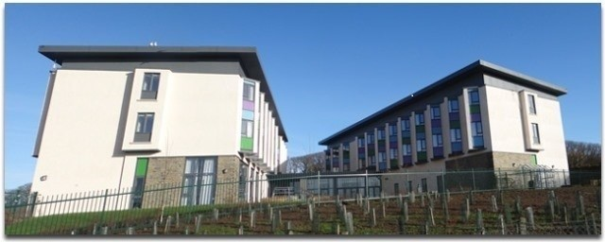

Winter Newsletter 2021
Welcome to our Winter edition of the Papdale Halls of Residence newsletter. Our newsletter is sent on a termly basis to advise you of future events, consultations, changes, achievements, and to encourage you to participate fully in the service we provide at Papdale Halls of Residence.

Christmas Break
Papdale Halls of Residence will close at 17:00 on Tuesday 21 December. Papdale Halls of Residence will reopen on Tuesday 04 January at 18:45 for North Isle pupils. Wednesday 05 January at 07:15 for inner and south isle pupils.

Taxis
Taxis have been ordered for all North Isle residents on a Sunday night to take them from the ferry to Papdale Halls. Taxis will run from after the October break to Easter Holidays. There will be taxis to collect evening residents on Sunday 24 October.

Refit
Remember the refit timetable runs from the 9th January to 12th March, please check the timetable for your ferry time.

Adverse Weather
Please be reassured that we have a procedure in place in the following scenarios
- Early sailing from North Isles on a Sunday.
- Ferry embarks from Kirkwall on a Friday afternoon and cannot dock returning to Kirkwall with pupils on board.
- Cancellation of sailings from Kirkwall on a Friday.

COVID-19
Papdale Halls continues to implement covid restrictions to mitigate the risk of infection, this includes staff and residents regularly washing and sanitising hands, wearing face coverings whilst moving around the building and an enhanced cleaning schedule remains in place.
We would like to take this opportunity to thank all our staff, residents and their parents for their support and understanding during the Corona Virus pandemic. At PHoR, our main priority is to keep everyone safe and well. All residents have had a huge contribution in helping us achieve this with their ongoing support and understanding of the changes we have to make within PHoR. Huge thanks to everyone.

Weekly Round up
We have recently introduced a weekly roundup which is emailed to all parents on a Friday. This gives an update of any important news, what activities have been on and a look at next week’s menu. We hope you are finding this useful and would love some feedback on it.

My favourite things

Violet McEwen– S4
Favourite Meal. | Toad in the Hole.
Favourite Film. | Spiderman into the spider.
Favourite Band. | Girl in red.
Favourite place. | Mae Sands.
Favourite colour. | Blue.
Who would I like to meet? | Criss Evans.
If I won £1 million I would. | Renovate a van + donate to charity.

Fraser– S5
Favourite Meal. | Marinated Steak.
Favourite Film. | Megamind.
Favourite Band. | Queen.
Favourite place. | Home.
Favourite colour. | Purple.
Who would I like to meet? | n/a.
If I won £1 million I would. | Be a millionaire.

Christine Robertson –Staff member
Favourite Meal. | Chinese food.
Favourite Film. | Saving Private Ryan.
Favourite Band. | Fleetwood mac.
Favourite place. | Home.
Favourite colour. | Black.
Who would I like to meet? | Billy Connelly.
If I won £1 million I would. | Share with family and friends.

What’s been happening in PHoR
With the changing Scottish Government guidelines, we have been able to offer some more activities this term. Residents have had the opportunity to participate in Halloween Buffet, Dungeons and Dragons, Crafts, Kahoot quizzes, Games hall and 3G pitch, Pool, board games, Knit and natter group, Mario kart and cooking. With the dark cold nights and a recent activities questionnaire we are expanding the amount and variety of activities on offer each week. Residents can find activity planners at reception and in the coffee bars.

Halloween Buffet
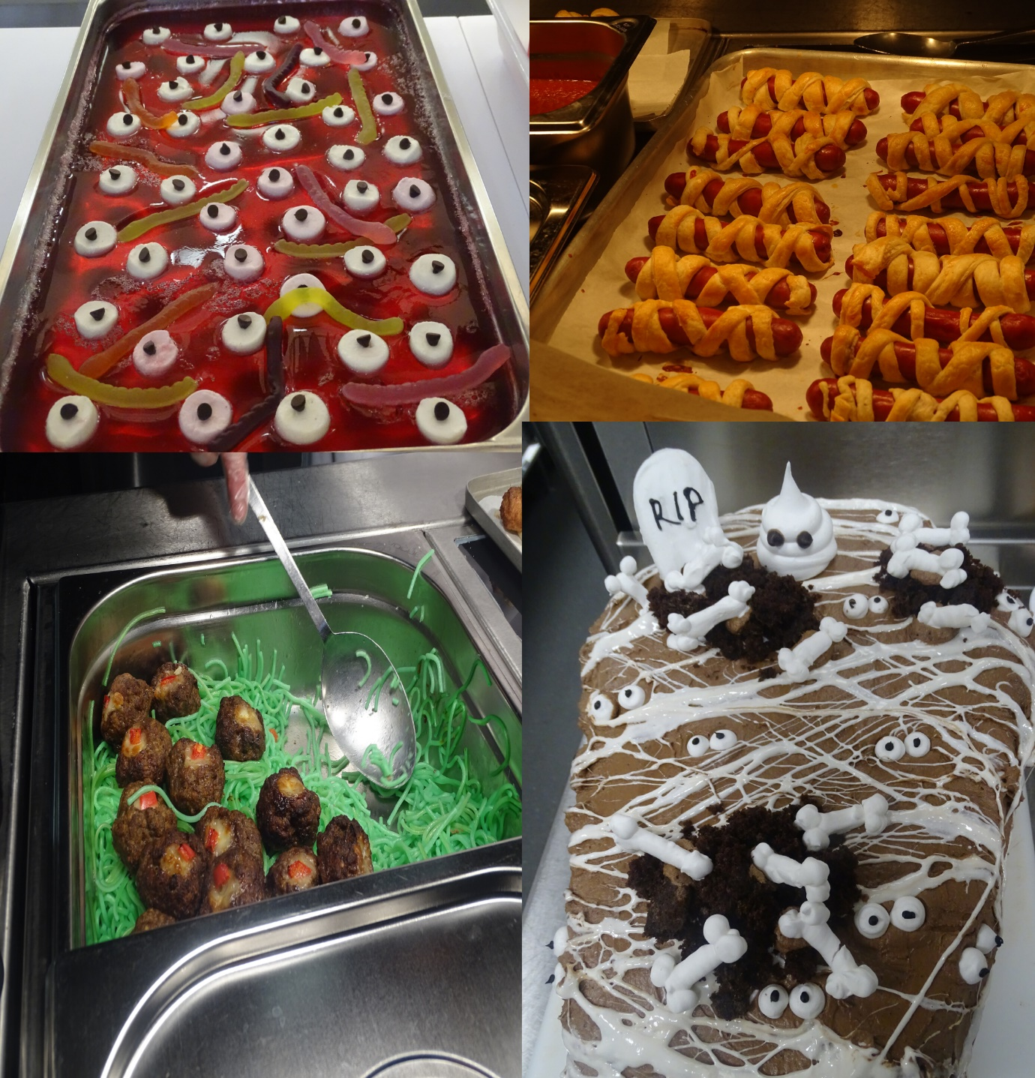

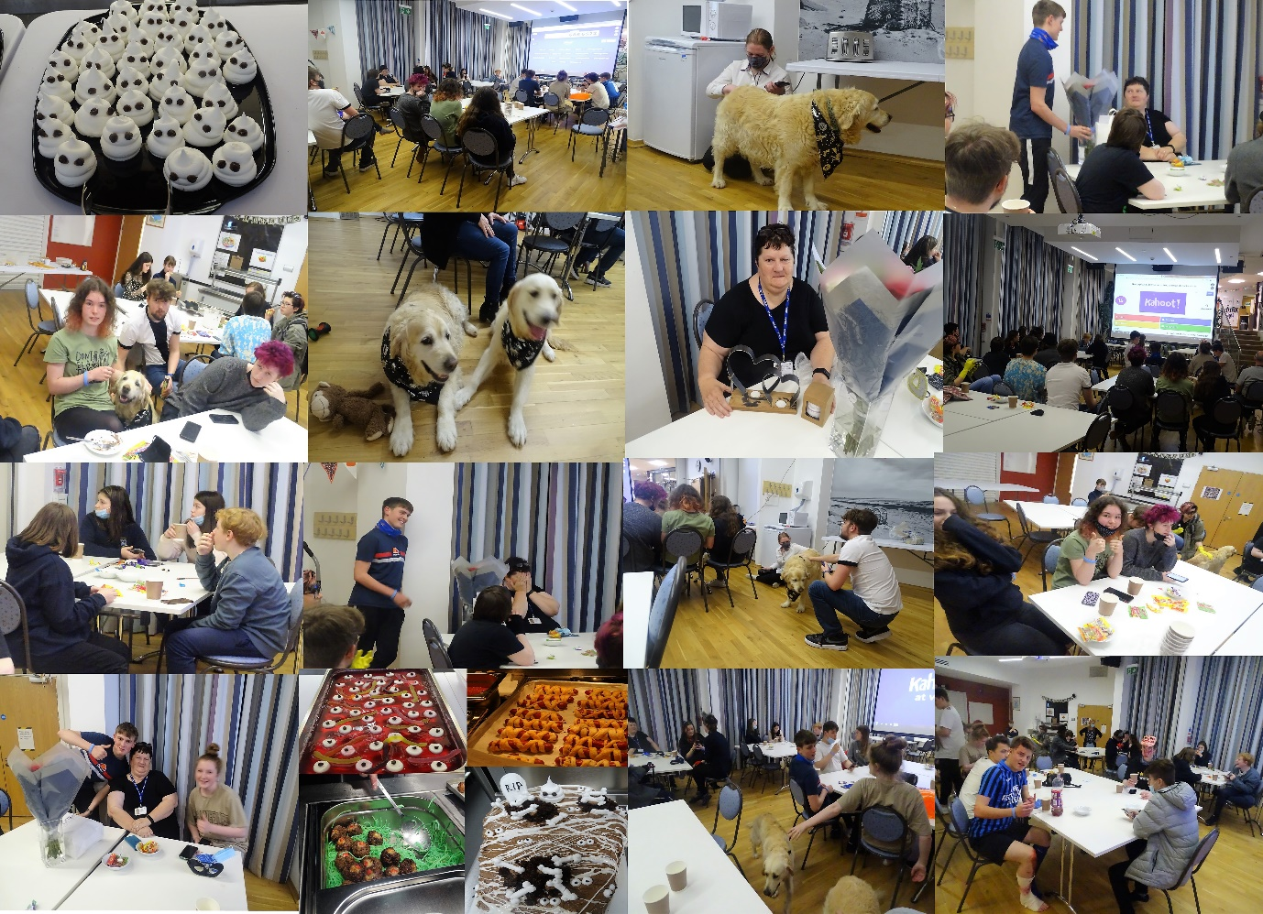

Dungeons and Dragons
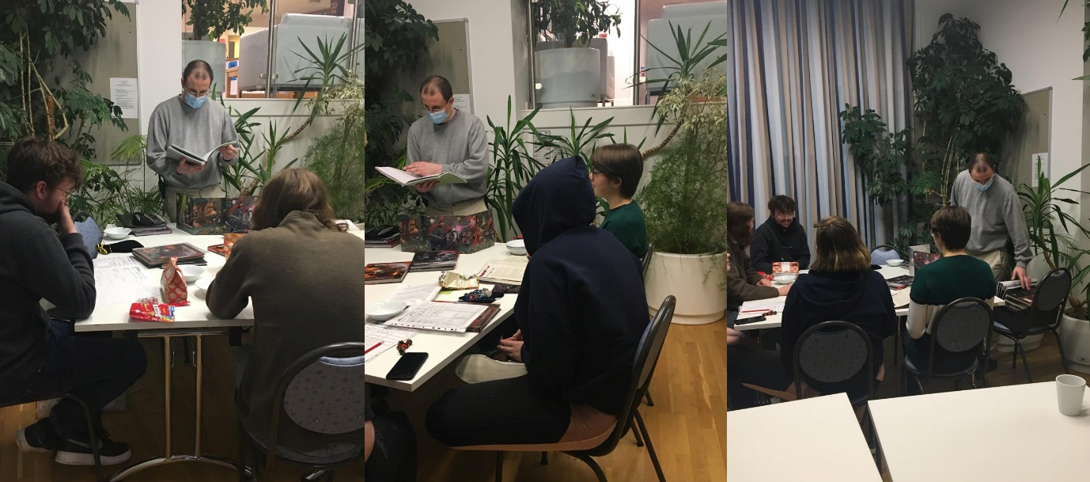

Making Waffles
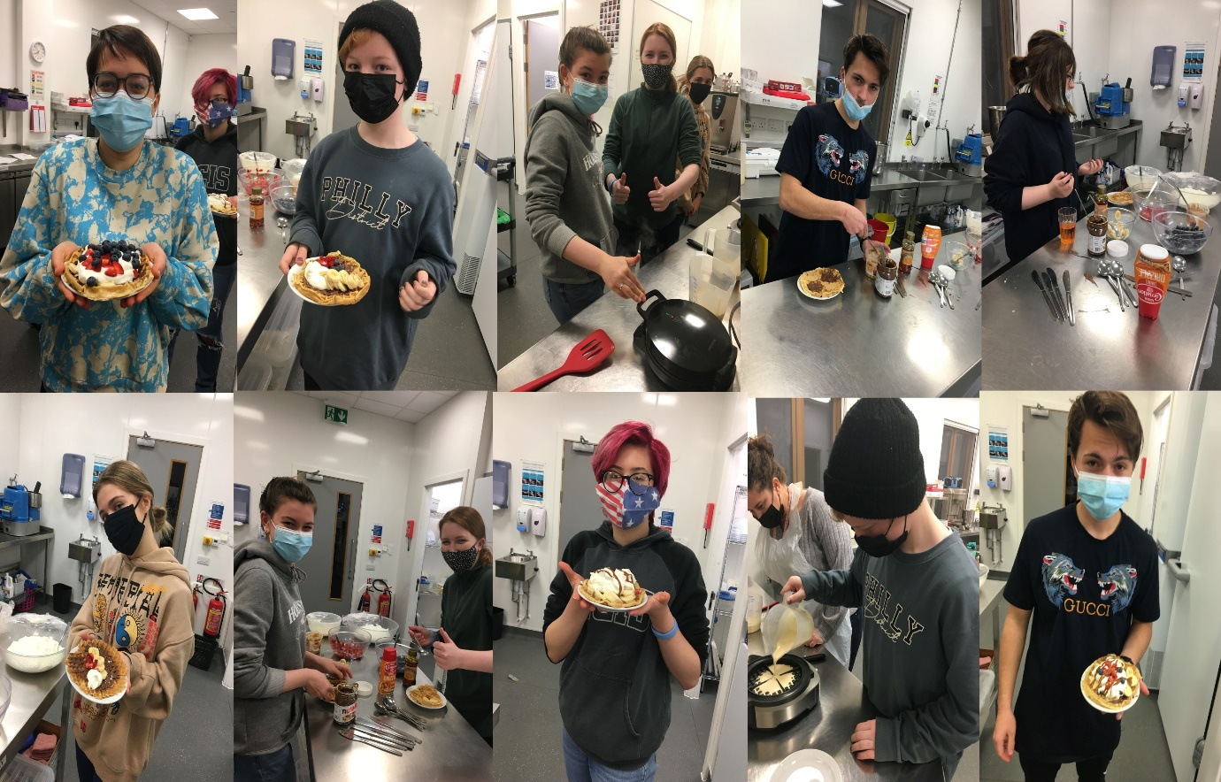

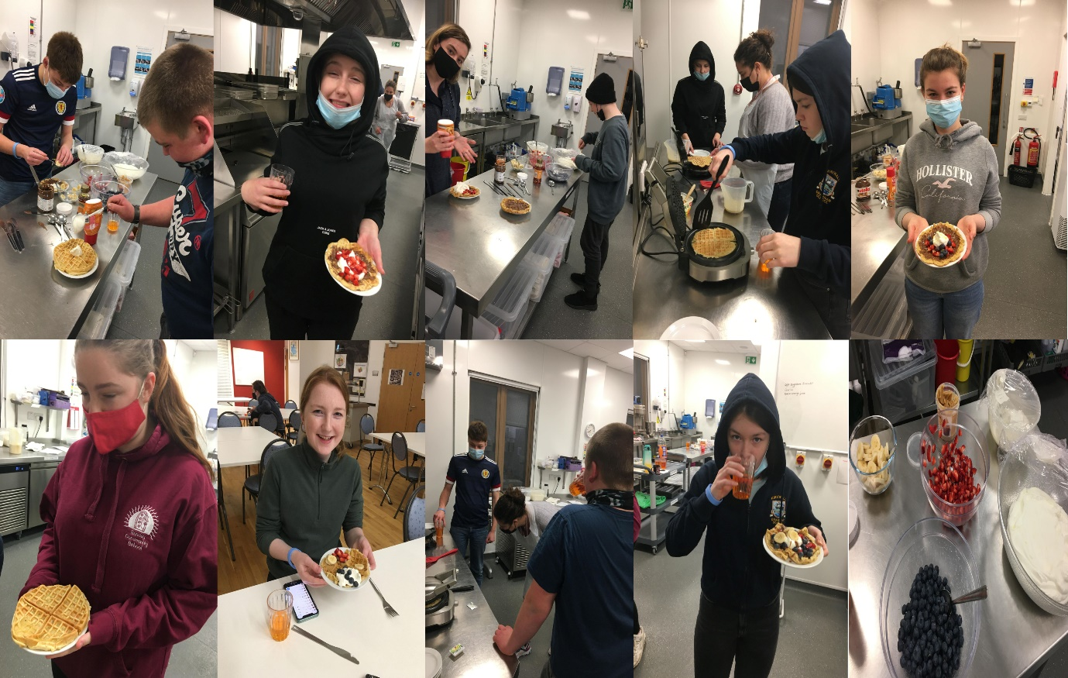

Mario Kart on the big screen
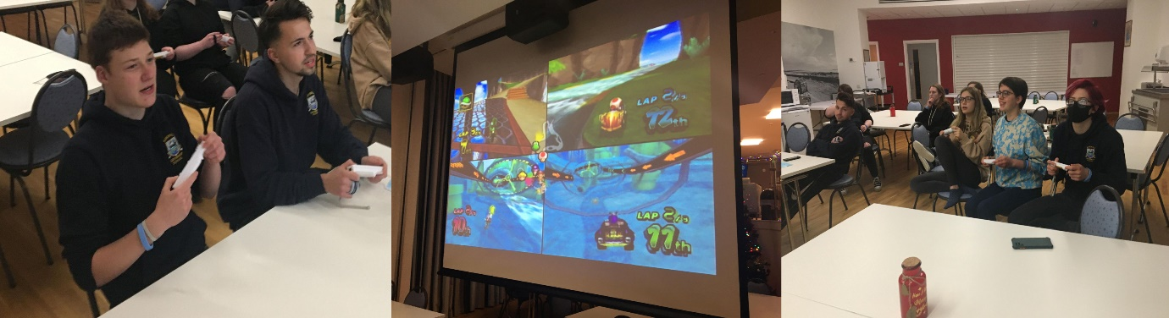

Children in Need
Children in need was a little quieter this year but staff and residents still managed to raise a fantastic £88.95. Residents had the opportunity to take a kahoot quiz, guess the sweeties, teddy tombola and a raffle. Tazmine Potts won the star prize of the Cadburys Bear with lots of lovely chocolates. Guess the sweeties in a jar was announced and Molly Friel was exact with her guess and took the prize of the jar filled with sweets. Kate Friel volunteered to take the money to present to Radio Orkney. Thank you to everyone who donated raffle prizes and special thanks to Robert for organising the events.
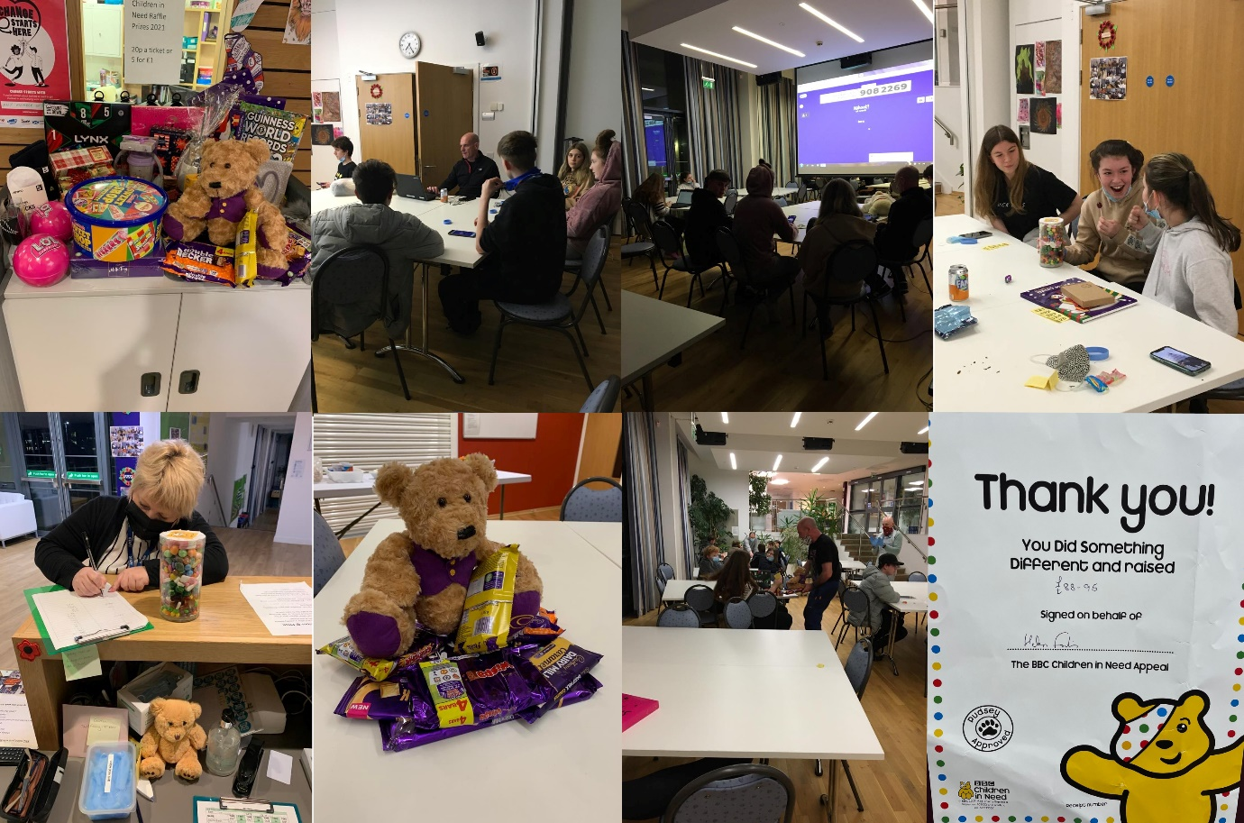

Baking Gingerbread

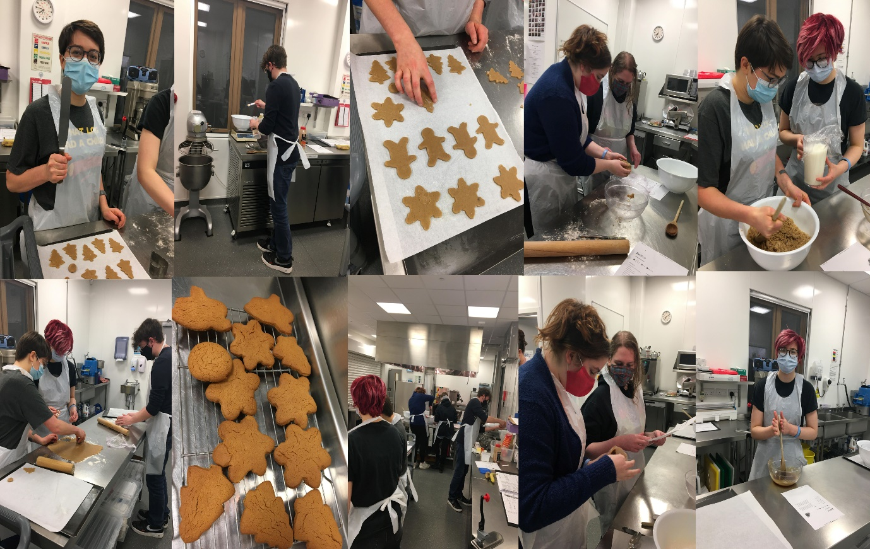

Bingo
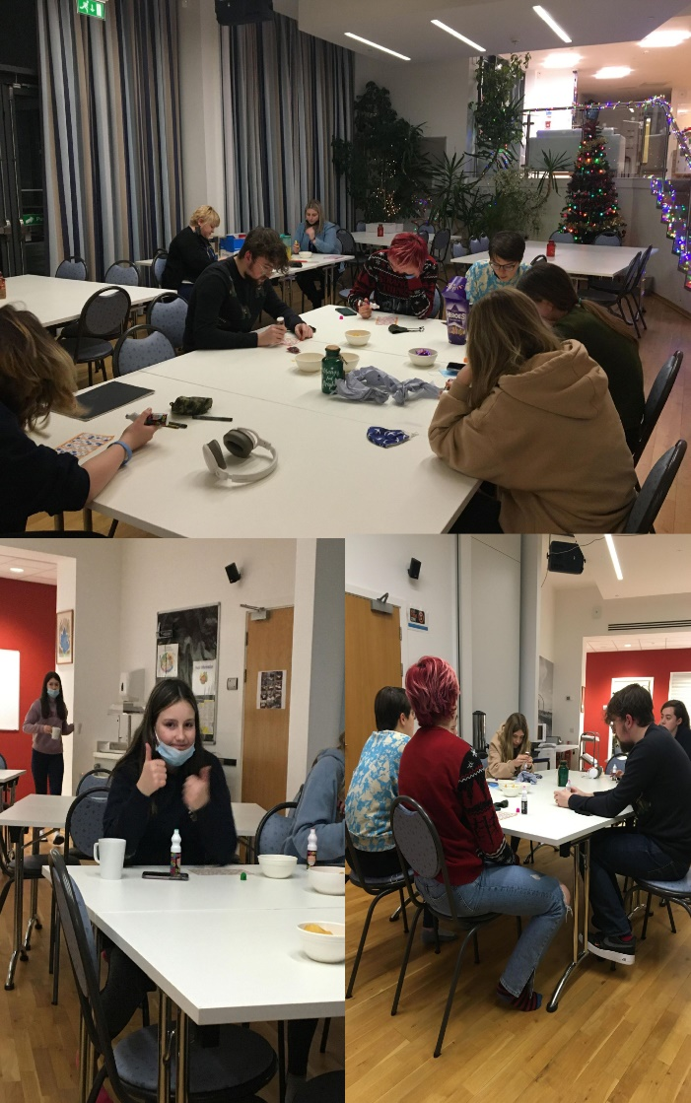

Christmas
Residents have had the opportunity to do some Christmas crafts, watch some Christmas movies and help decorate our Christmas trees.
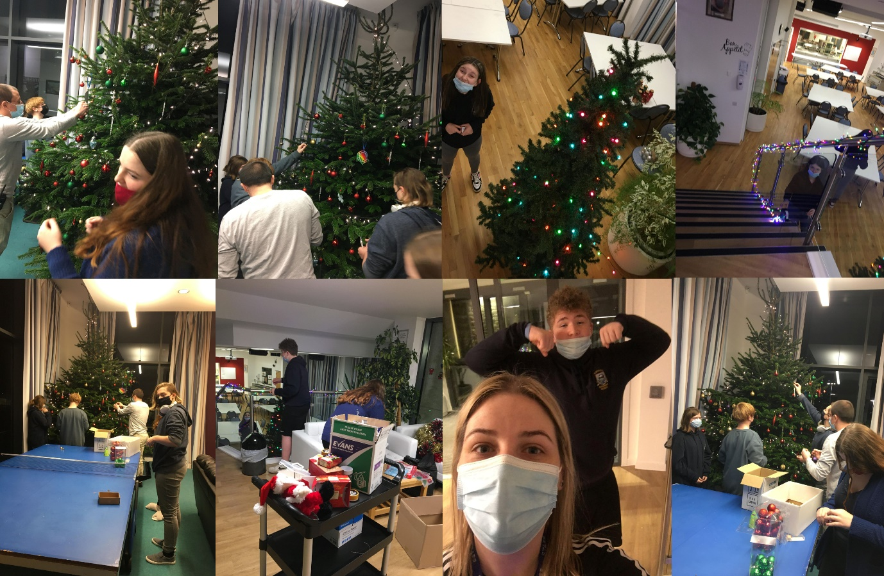

Christmas Meal
Our Christmas meal was held on the 15 December. Thank you to the kitchen team for a lovely meal, it was enjoyed by all.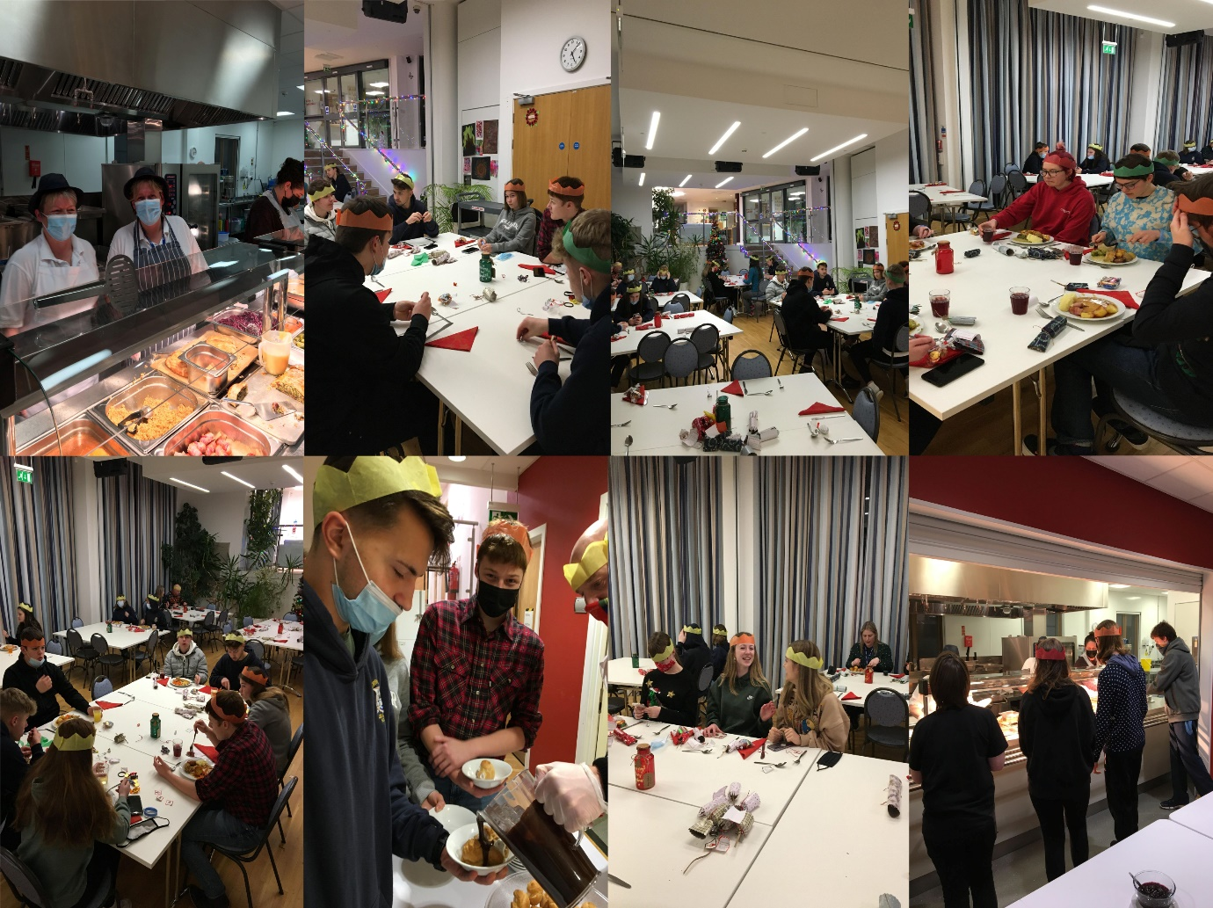
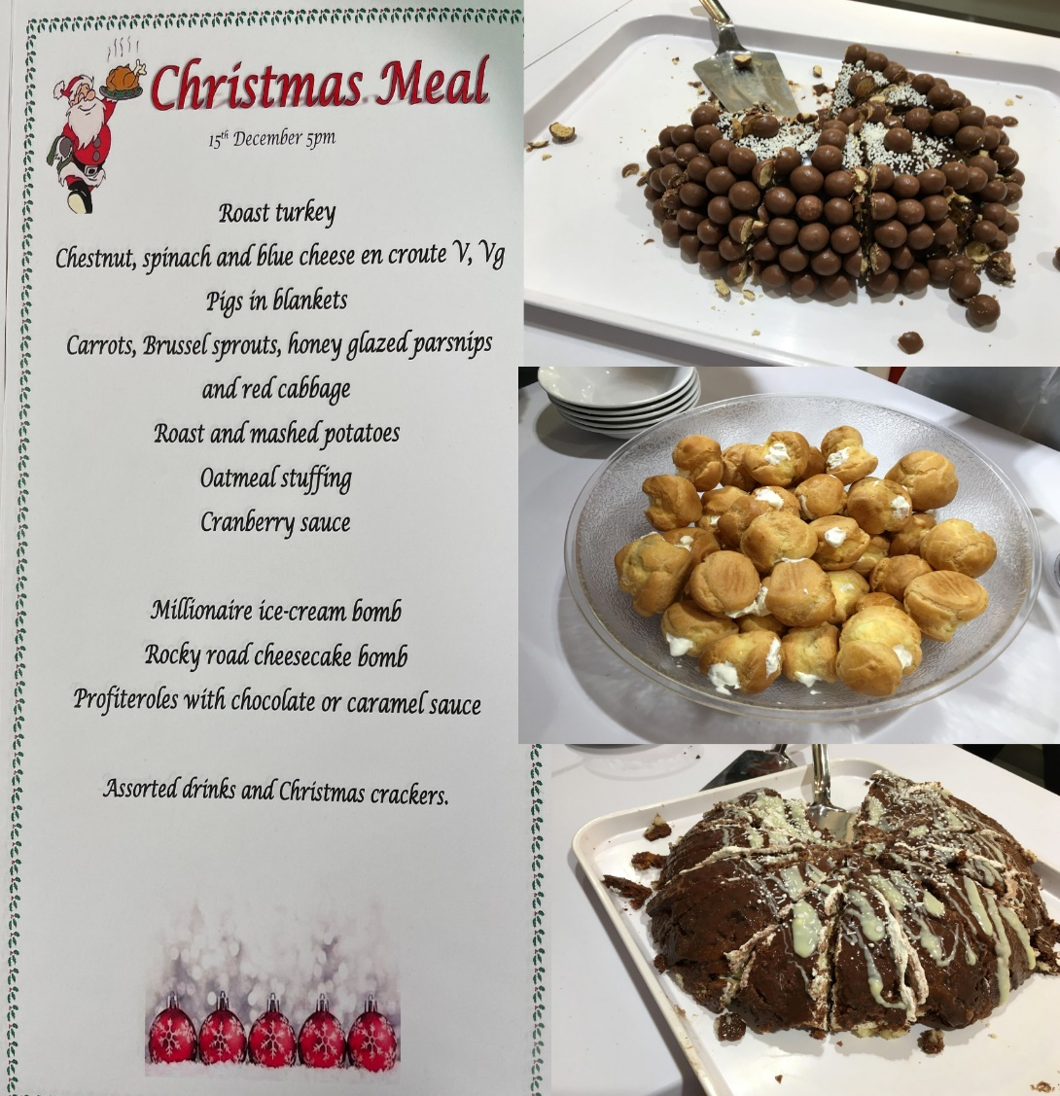

Supported Study
Supported study is part of the Junior Support Plan for S1-S2 residents and is a chance to develop positive relationships between the younger residents and staff. As well as homework they may have, residents are given the opportunity to take part in a variety of activities and workshops, that encourage team work, communication, inclusion and developing knowledge and awareness of relevant topics.
This term has consisted of:
- Homework.
- Boardgames.
- Wii just dance.
- Baking.
- Walk to see remembrance lights
- Quiz.
- Crafts.
- Anti bullying workshops.

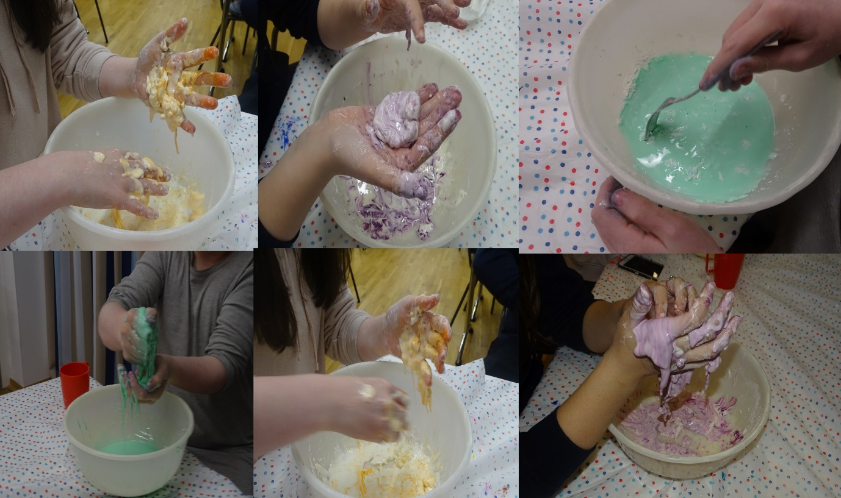

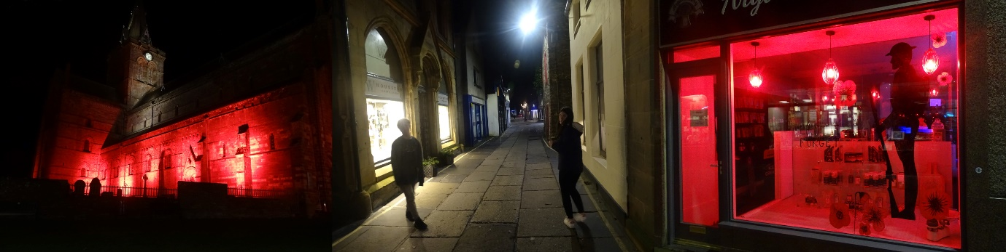
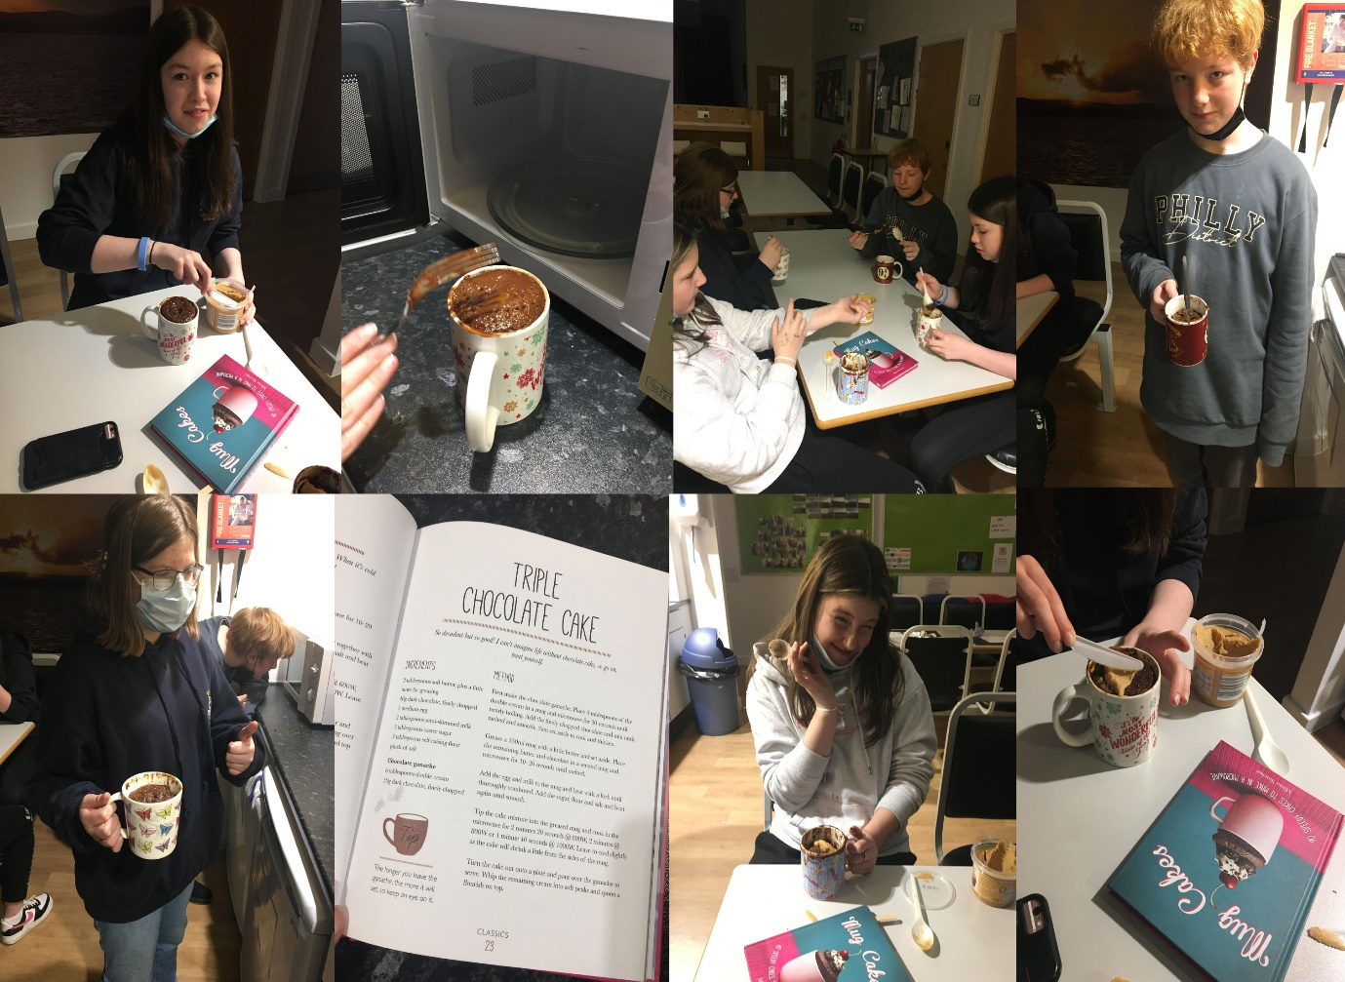

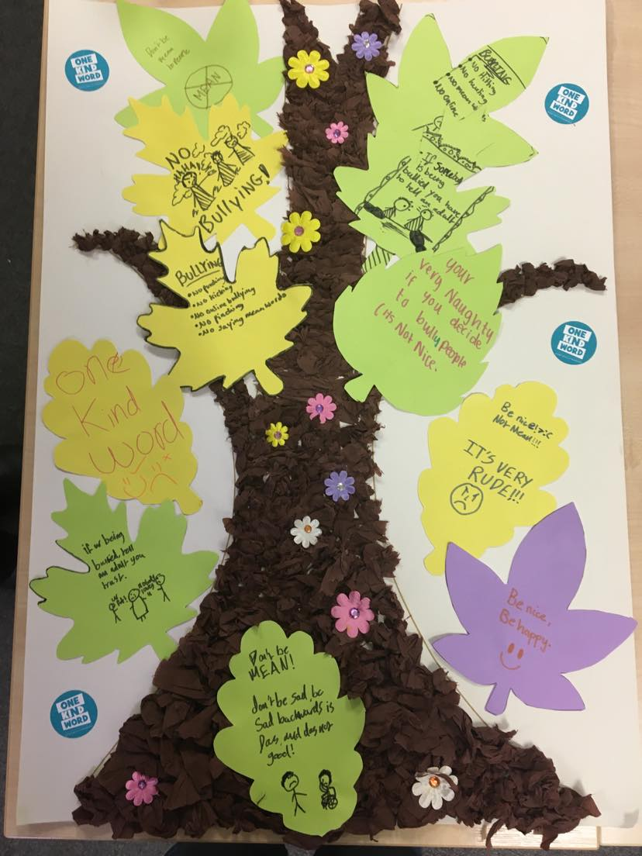

Wanted You to Ken Board
The wanted you to ken suggestion box is located at participation board outside the library. This is for complaints, comments and suggestions. This is checked weekly by management and we welcome your opinions on all aspects of life at the Halls, including areas where you feel we are doing well. This term there has been no entries into the box.
Suggestion. | Outcome.
4K tv | We do need a new tv, and will look into purchasing one in the near future.  A new 55 inch smart tv has now arrived and will go up on the wall shortly.
PS5. | this will be purchased when they become available
New guitar | Added to our wish list.

Bicycle funding
Our Assistant House Parent David Hamilton applied for some funding through Cycling Scotland to try and get some bikes for use by our residents in October. It is very difficult for our residents to take their own bikes in to the Halls because of the distances involved, trying to get their bikes back home for use at the weekends, and some of our residents flying in and back home to school.
The funding application has been successful, and we will be able to purchase six brand new bikes in the new year. The bikes will be in a range of sizes to suit all our residents and will be kept in our bike shed where the residents will be able to access them whenever they need. The bikes will also have all the necessary safety equipment such as – lights, helmets etc. The bikes will be properly maintained with an annual service to ensure that they are kept in a good and roadworthy condition.
As a condition of the funding agreement when the bikes are not in use at PHoR they can be made available to other schools in Mainland Orkney for use at the weekends or during school holidays.

Staff update
To help you put faces to names her are some staff photos and a list of their length of service, role and qualifications held to meet SSSC Registration for School Care Accommodation.
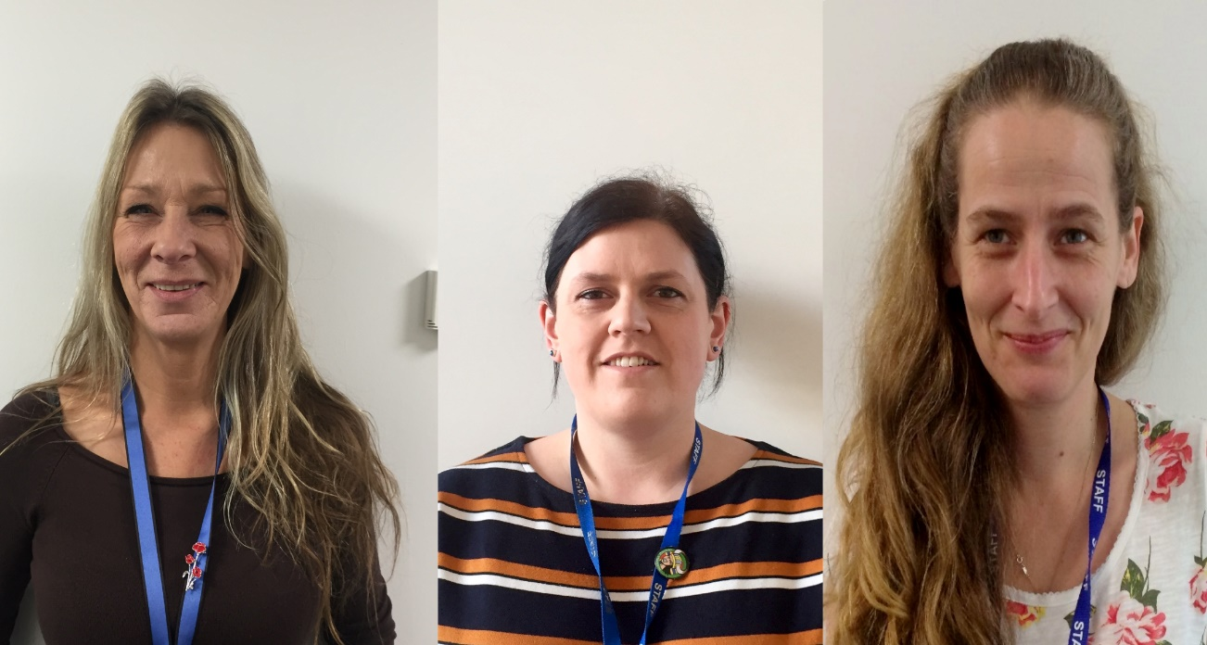
Name | Post  Contract  length of service | PDA Management and Leadership | SVQ4 Health & Social Care | SVQ3 Health & Social Care | HNC Health & Social Care
Debbie Sclater | Registered Manager  35hrs  13 years
Danielle Leslie | Senior House Parent  37hrs  6 years
Claire Jacobsen | Senior House Parent  37hrs  5 years

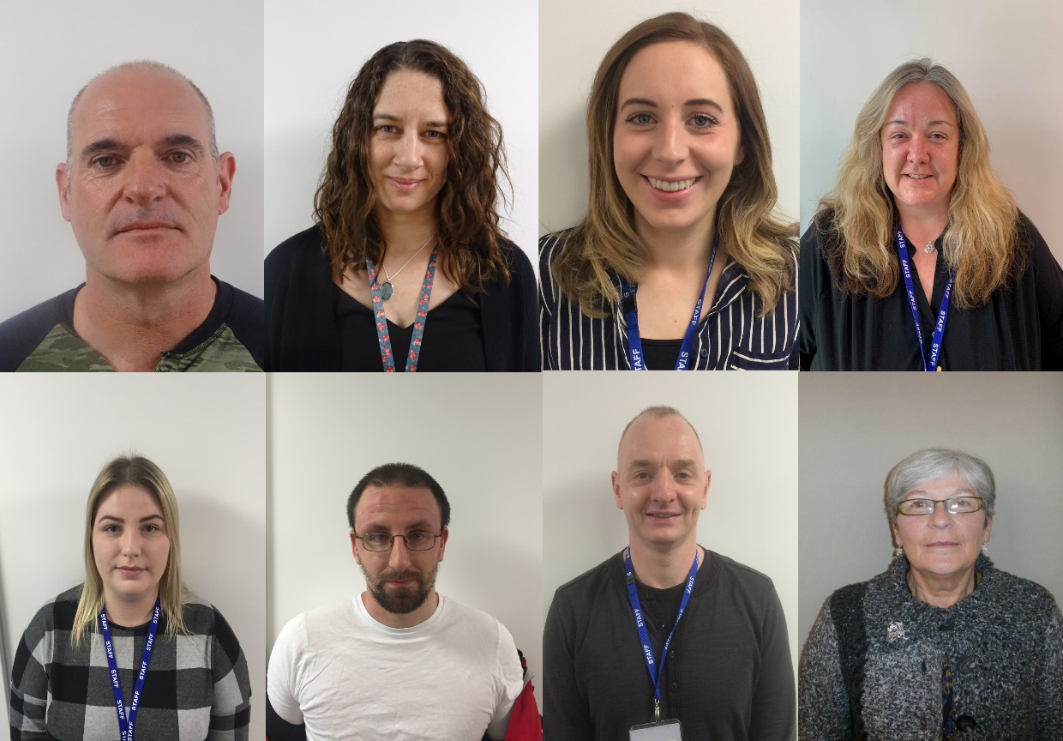
Name | Post  Contract and length of service | SVQ3 Health & Social Care  (Or Equivalent) | HNC Health & Social Care  (Or Equivalent)
Robert Macnamara | House Parent  37hrs  16 years
Joanna Wood | House Parent  37hrs  6 years
Rachel Tait (currently on maternity leave) | House Parent  29hrs  5 years
Christine Robertson | House Parent  maternity cover 29hrs
Lana Linklater | Assistant House Parent - 24.6hrs  House Parent-7hrs  7 years
Thomas Mills | Assistant House Parent  27.3hrs  7 years
David Hamilton | Assistant House Parent  22hrs  5 years
Sheelagh Sneesby | Night Care Assistant  21.25hrs  16 years
Vacant  (position filled awaiting start date) | Night Care Assistant  21.25hrs
Vacant  (position filled awaiting start date) | AHP  16hrs

Name | Post  Contract and length of service | SVQ3 Health & Social Care  (Or Equivalent) | HNC Health & Social Care  (Or Equivalent)
Tracey Stanger | Relief RHP + AHP  5 years
Dylan Pepper | Relief RHP  1 year
Daniel Baird | Relief AHP  2 years
Tara Silgoner | Relief AHP  3 years
Brian Darby | Relief AHP  >1 year

Charity work
Staff at Papdale Halls have worked together this term to donate to the Rotary Club shoe box appeal and the loving homes for dog’s rescue.
The Rotary Shoebox Scheme is a registered charity that sends boxes full of gifts to those of all ages, that are disadvantaged in Eastern Europe. This Scheme has now been running for over 25 years. Originally set up to provide gifts to children at Christmas, now the scheme has expanded and distributes gifts all year round. As well as providing gifts to children in care and in disadvantaged families, the scheme also provides gifts to teenagers, refuges, and to older people with no supporting families. Papdale Halls filled and donated 7 boxes, thanks to Houseparent Joanna Wood for organising this.
Orkney Loving homes for Dogs is a charity that relies heavily on public donations to rescue “poundies” (Poundies are dogs that are abused, dumped, abandoned; unwanted souls that find themselves with 7 days to live in council pounds across the UK). The charity hopes to give them a fresh start in life and to show them that there is still love and caring in the world after their traumas. They are an all-breed rescue and take a variety of dogs to rehome including problem cases and those requiring rehabilitation including severe abuse cases and bait/fighting dogs. Staff have collected treats, toys and treats for the dogs that will be in the rescue over Christmas. Thanks to our Janitor Mick for organising this.
Thanks to all the staff who donated to these two worthy causes.
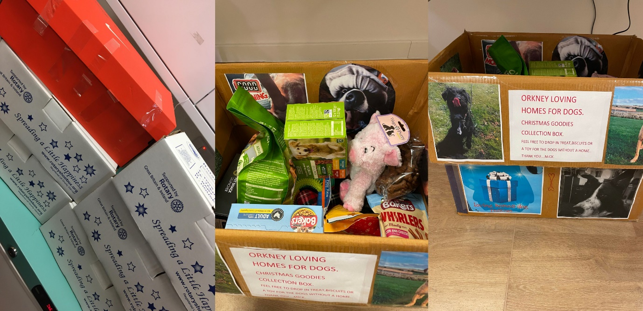

Monthly Campaign Board – Kindness at Christmas.
Lana’s has chosen Kindness at Christmas as Decembers theme for the monthly campaign. Information displayed on the board will cover a variety of topics, these include:
- money and budgeting for Christmas.
- Self-care tips, ideas and suggestions
- Easy festive cooking and bakes to do at home
- Christmas and mental health
- Covid during winter

Prelims
Some of your children will be undertaking prelims soon, if anyone needs any help in getting a study plan organised please speak to staff. The library is open every night for study for those who wish to use it and other quiet areas can be provided.

KGS Above and Beyond Nominations.
PHoR staff team received a nomination from KGS - “our pupils are very lucky to
have such incredible support from a kind, creative and simply marvellous group of
staff.” We are all extremely proud and heartened to have received this
acknowledgement, thank you KGS staff team.

PHoR Website
We update our news section of the website regularly with events, activities and any other news, so please feel free to browse and let us have any comments or suggestions. Please see here for any up to date information, you can visit our website at www.orkney.gov.uk/PHoR. Our website is in an accesible format and features ReciteMe.

Data Protection
The information you have provided Orkney Islands Council and Papdale Halls of Residence with about your child is in order that we can provide your child with accommodation and the support they need while staying with us.
We will also at times ask the school for some information about your child, about their likes and dislikes and about any needs they may have. This will help us provide the right support for your child.
We are legally obliged to collect all this information by the Care Inspectorate who regulate and inspect Papdale Halls of Residence.
More information on how Orkney Islands Council will use your information, your rights and about Orkney Islands Council, as a Data Controller, is available on the Orkney Islands Council’s website.
https://www.orkney.gov.uk/Online-Services/privacy.htm
We hope you enjoyed reading our newsletter and welcome any feedback. Please feel free to contact us if you have any queries or comments
Papdale Halls of Residence, By Papdale Road, Kirkwall, KW15 1QN.
Telephone: 01856876060.
Email: admin.papdalehalls@orkney.gov.uk or Danielle.leslie@orkney.gov.uk

